EDLINGHAM PARISH COUNCIL
AGENDA PAPER
You are hereby summoned to attend an ordinary meeting of Edlingham Parish Council to be held at Thrunton Fishery on Monday 2nd December 2019 commencing at 730pm, for the purpose of transacting the business contained within this Agenda.
A five minute participation session will be held for members of the public before the meeting commences

2019/42 Apologies for Absence

2019/43 Declaration of Interests
Members are invited to disclose any Disclosable Pecuniary Interests or other personal interests they may have in any of the items of business on the agenda in accordance with the Code of Conduct.

2019/44 County Cllr Update

2019/45 Minutes of previous meeting held 21st August 2019
2019/46 Matters arising from previous meeting held 21st August 2019

2019/47 Planning
2019/47/01 Planning Applications received:
2019/47/02 Approval of Planning Application received
- 19/00664/FUL: 4 Overthwarts Farm, Swinhope Cottage, erection of 3m x 3m summerhouse in corner of front garden
- 19/03842/VARYCO; Station Cottage, The Old Station Track, Variation of Condition 2 to 18/04518/FUL in order to substitute plans

2019/48 Correspondence
2019/49 Finance
2019/49/01 To approve precept requirement 2020-2021

2019/50 Neighbourhood Management
2019/50/01 To discuss and approve request to place seat within the parish

2019/51 Edlingham Community Association
2019/52 Urgent Business
2019/53 Date of Next Meeting

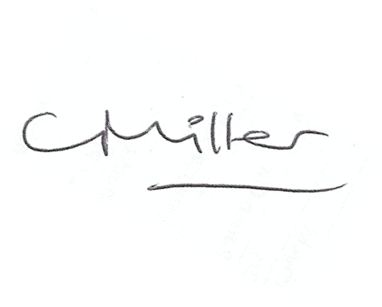
Claire Miller
Parish Clerk

20th November 2019

www.parish-council.com/edlingham/links.asp

