EDLINGHAM PARISH COUNCIL
AGENDA PAPER
You are hereby summoned to attend a meeting of Edlingham Parish Council to be held at Thrunton Fishery on Tuesday 12th February 2019 commencing at 730pm, for the purpose of transacting the business contained within this Agenda.
A five minute participation session will be held for members of the public before the meeting commences

2019/01 Apologies for Absence
2019/02 Declaration of Interests
Members are invited to disclose any Disclosable Pecuniary Interests or other personal interests they may have in any of the items of business on the agenda in accordance with the Code of Conduct.

2019/03 County Cllr Update
2019/04 Minutes of previous meeting held 20th November 2018
2019/05 Matters arising from previous meeting held 20th November 2018
2019/06 Planning
2019/06/01 Planning Applications received
2019/06/02 Approval of Planning Application received

2019/07 Correspondence
- Confirmation of payscales from 1/4/19
- Northumberland Draft Local Plan – Consultation 30/1 to 13/3/19
- CPRE newsletter

2019/08 Finance
2019/08/01 The following payments are to be authorised:
- C Miller – annual salary and expenses - £361.52
- HMRc – PAYE on above - £70.00

2019/08/02 Grant request received
- Alnwick’s Bailiffgate Museum & Gallery

2019/09 Neighbourhood Management

2019/10 Edlingham Community Association

2019/11 Review of internal controls/internal auditor/asset register/risk assessment and insurance cover

2019/12 Urgent Business

2019/13 Date of Next Meeting

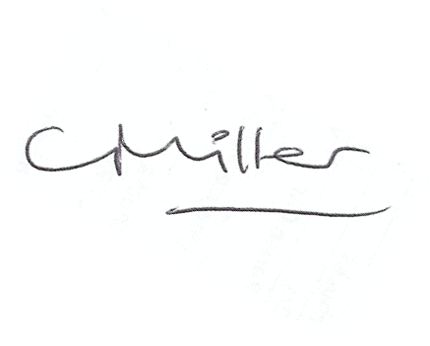
Claire Miller
Parish Clerk

1st February 2019

www.parish-council.com/edlingham/links.asp

