Minutes of Electronic meeting of Edlingham Parish Council held at 8pm on Tuesday 21st July 2020
Those present: Cllr C Blythe (Chairman), Cllr R Robson, Cllr N Hargreaves, Cllr G Herdman, Cllr T Drummond, Cllr A Hall,
C Miller (Clerk), W Pattison (County Cllr)

2020/20 Apologies for Absence

2020/21 Declaration of Interests

2020/22 Minutes of previous meeting held 24th February 2020
The minutes of the previous meeting held 24th February 2020 were accepted as a true record.

2020/23 Matters arising from previous meeting held 24th February 2020
2020/23/01 Definitive Map and Statement and recording of highway status – Confirmation of Definitive Map Modification Order (No 17), 2019 Byway Open to All Traffic No 30
2020/23/02 Road maintenance within the parish

2020/24 County Cllr Update

2020/25 Planning
2020/25/01 Planning Applications received:
- 20/00878/LBC: Former Coach House and Kennels, Lemmington Hall, Listed Building Consent: Enclosure of terrace with glazed screen, new stove and flue, amendments to kitchen doorway AND APPROVED
- 20/00628/FUL: Former Coach House and Kennels, Lemmington Hall: New air source heat pump and solar panels. Enclosure of terrace with glazed screen, removal of chimney, new stove and flue, amendments to kitchen doorway and kitchen rooflights AND APPROVED.
2020/25/02 Notice of Planning Application appeal to Planning Inspectorate
- 19/00974/FUL: Land North East of Black Lough change of use from agricultural to C3 unit leisure development and associated groundworks as part of farm diversification
2020/25/03 Planning Applications relating to Lemmington Hall

2020/26 Correspondence

2020/27 Finance
2020/27/01 To approve the following payments
- NALC – annual subscription - £68.84
The payment was authorised

2020/28 Neighbourhood Management

2020/29 Edlingham Community Association

2020/30 Audit of Accounts year ending 31/3/20
2020/30/01 To consider and agree any actions arising from the report of the internal auditor
There were no matters arising from the report of the internal auditor.

2020/30/02 To approve the Governance Statement
It was resolved to approve the governance statement.

2020/30/03 To approve the draft annual accounts for 2019/2020
It was resolved to approve the accounts for 2019/2020.

2020/30/04 To approve the Accounting Statement and explanation of variances
It was resolved to approve the accounting statement and explanation of variances.

2020/30/05 To approve the Exemption Certificate
It was resolved to approve the exemption certificate.

2020/31 Website Accessibility Regulations
Regulations were being introduced relating to local government web-sites having to be accessible to all. The current free Spanglefish site could be upgraded for an annual charge of £105

2020/32 Superfast broadband for rural communities

2020/33 Urgent Business
2020/34 Date of Next Meeting

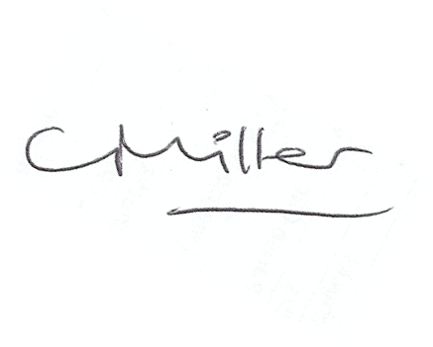
Claire Miller
Parish Clerk

11th July 2020

www.parish-council.com/edlingham/links.asp

