EDLINGHAM PARISH COUNCIL
AGENDA PAPER

You are summonsed to attend an ordinary meeting of the Parish Council to be held at 8pm on Tuesday 17th August 2021 at Thrunton Fishery, for the purpose of transacting the business contained within this Agenda. The public are welcome to observe
A five minute participation session will be held for members of the public before the meeting commences

2021/31 Apologies for Absence
2021/32 Declaration of Interests
Members are invited to disclose any Disclosable Pecuniary Interests or other personal interests they may have in any of the items of business on the agenda in accordance with the Code of Conduct.

2021/33 Co-Option Vacancies
2021/34 Minutes of previous meeting held Monday 17th May 2021

2021/35 Matters arising from previous meeting held Monday 17th May 2021
2021/35/01 Road maintenance and winter services within the parish
2021/35/02 Problems due to off road vehicles within the parish

2021/36 County Cllr Update

2021/37 Planning
2021/37/01 Planning Applications received
2021/37/02 Approval of Planning Application received
2021/37/03 Planning Applications relating to Lemmington Hall
2021/37/04 Northumberland Local Plan Examination – Consultation on Main Modifications
2021/37/05 The Northumberland Sandstone Ridges & Vales – a Valued Landscape – Alison Farmer Associates January 2021 (the Study) – Request from Northumberland and Newcastle Society for EPC to give its support to the conclusions of the report

2021/38 Finance
2021/38/01 To approve the following payment
- Plexus Media Ltd – Spanglefish – web-site hosting fee

2021/39 Neighbourhood Management
2021/39/01 Notice of request for Tree Preservation Orders within the parish

2021/40 Superfast broadband for rural communities

2021/41 To approve Local Transport Plan priorities for 2022-2023: Resurfacing of Lemmington Bank to Lemmington crossroads; resurfacing of road into Thrunton and creation of car park near to Edlingham church requested 2021-2022.

2021/42 Date of Next Meeting
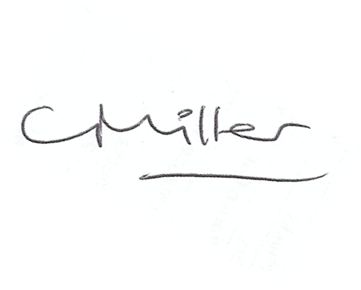
Claire Miller
Parish Clerk

7th August 2021

www.parish-council.com/edlingham/links.asp

