Minutes of the annual meeting of Edlingham Parish Council held at Bolton Village Hall on Tuesday 17th of May 2016 at 8.00pm
Those Present Cllr C Blythe (Chairman), Cllr J Herdman, Cllr G Herriman, Cllr A Hall, Cllr T Drummond, Cllr N Hargreaves, Cllr G Herdman, Kate Cairns (NCC)
2016/14 Apologies for Absence

2016/15 Election of Officers – Cllr H Macgregor attended for meeting commenced and regretfully tendered his resignation, Cllr C Blythe thanked him for his service to the parish.
Cllr Herdman proposed Cllr C Blythe as Chairman, Cllr N Hargreaves seconded, all in favour
Cllr C Blythe proposed Cllr T Drummond as Vice Chairman, Cllr J Herdman seconded, all in favour

2016/16 Declaration of Interests
There were no declaration of interests.

2016/17 Opportunity for members of the public to raise any matter on the agenda
None.

2016/18 County Cllr Update
K Cairns reported on items relating to the parish over the past 12 months.
- Meeting had been held with NCC Highways regarding road safety improvements at moorhouse crossroads, matter ongoing.
- NCC officers had met with residents regarding Lemmington Hall planning application, matter ongoing.
- No overnight camping signage had been placed at Edlingham Castle.
- State of roads within the parish an ongoing concern.
- Some tree/pothole works had been carried out on A697.
- NCC had visited site regarding Bridge of Aln signage, however Cllr C Blythe confirmed they had been looking at wrong side of road.
- Ditching work at Broome Park would be actioned this week.
- Cattle grid had been renewed on road past Lemmington Hall.
- Potholes on Lemmington Bank had been actioned.
The following were discussed:
- Central Government fund for flood repairs for rural areas to possibly be accessed.
- Rumble strips were not advised for moor crossroads
- New school partnership system to be implemented September 2016.
- There were growing numbers of children in need within the county, where resources were most needed.
- Three NCC planning committee system had been reviewed, with system reverting to two committees.
- It appeared constant changes seemed to occur at County Hall.

2016/19 Minutes of previous meeting held 15th February 2016
The minutes of the previous meeting were agreed as a true record.

2016/20 Matters Arising from previous meeting
None.

2016/21 Planning
2016/21/01 Planning Applications
- 16/00762/VARYCO: Mr E McCallum, Variation of conditions 2, 3 and 4 and removal of condition 9 relating to planning application 12/00645/VARYCO
2016/22 Correspondence
- Nothing relevant to Edlingham parish
2016/23 Finance
2016/23/01 The following invoices were authorised:
- Bolton Village Hall - £8.00 – rent of hall
2016/23/02 Financial Statement as at 31/3/16

Opening Balance 1/4/16 £1198.58
Receipts 2015/16 | £ | Payments 2015/16 | £ | Budgeted  Receipts 2016/17 | £ | Budgeted  Payments 2016/17 | £
Precept | 700 | Salary/expenses | 319.48 | Precept | 700 | Salary/expenses | 330
HMRC | 7.00 | Rent of hall | 32.00 |  |  | Rent of hall | 32.00
 |  | Subscriptions | 60.26 |  |  | Subscriptions | 62.00
 |  | Insurance | 171.61 |  |  | Insurance | 180.00
Total | £707 |  | £583.35 |  | £700 |  | £604.00

Estimated Closing Balance 31/3/17 £1322.23

2015/23/03 Audit of Account y/e 31/3/16
Section 1, Annual Governance Statement and Section 2 Accounting Statements 2015-2016 were agreed and authorised.

2016/24 Neighbourhood Management
- Local Transport Plan requests 2016-17 would be discussed at next meeting.
- Potholes an ongoing problem.
- Wall on Cllr N Hargreaves land was to be rebuilt by NCC following incident, however 5-6 years later, no action.

2016/25 Urgent Business
Layby where mast is, near to moor crossroads suffering ever increasing problem with litter, Clerk to contact NCC.

2016/26 Date of Next Meeting
The next meeting of Edlingham Parish Council will be held on Tuesday 16th August commencing 8pm in Bolton Village Hall

The meeting closed at 745pm.

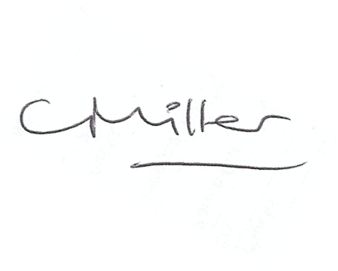
Claire Miller
Parish Clerk

