EDLINGHAM PARISH COUNCIL
Minutes of meeting of Edlingham Parish Council held at Bolton Village Hall on Wednesday 15th August 2018 commencing at 8pm
Those Present: Cllr C Blythe (Chairman), Cllr T Drummond, Cllr R Robson, County Cllr W Pattison

2018/33 Apologies for Absence
Cllr G Herdman, Cllr N Hargreaves

2018/34 Declaration of Interests
There were no Declaration of Interests.

2018/35 County Cllr Update
County Cllr update had been circulated. Cllr T Drummond reported current broadband works within the parish are of concern, - due to incorrect materials being installed some works having to be re-done. Openreach have a budget of £1700/dwelling and do not wish to exceed this, however Central Government advise this amount should be exceeded if necessary, with the current situation a stand-off. County Cllr to request update from S Pringle

2018/36 Minutes of previous meeting held 23rd May 2018
The minutes of the previous meeting held 23rd May 2018 had been circulated.

2018/37 Matters Arising from previous meeting held 23rd May 2018
- Areas of concerning regarding potholes to be passed to County Cllr.

2018/38 Planning
2018/38/01 Planning Applications received
- 18/02499/FUL: Learchild Crossing Cottage – construction of rear single storey extension with roof terrace and open porch to side

2018/38/02 Approval of Planning Application received
No approval of planning applications had been received.

2018/38/03 Northumberland Local Plan Consultation
Wind turbines at South Charlton of concern to neighbouring parishes.

2018/39 Correspondence
- CPRE – newsletter
- County Council – disposing of hazardous waste
- County Council – Safety Scheme, B6341/C90 Lemmington Bank Crossroads – vegetation to be cut back and new signage to be placed. Ever increasing signage at Moorcrossroads of concern.
- County Council – notice of Annual Town and Parish Conference 11/10/18

2018/40 Finance
2018/40/01 The following invoices had been received for payment:
- Bolton Village Hall rent of hall - £8.00
- NALC – annual subscription - £65.64

2018/41 Neighbourhood Management
No issues.

2018/42 Adoption of documents relating to General Data Protection Regulations (GDPR): Information & Data Protection Policy; Publication Scheme and Councillor Details; Subject Access Request Form; Privacy Notice; Email Contact Privacy Notice; Councillor Privacy Notice; Document Retention Policy
Deferred until next meeting.

2018/43 Edlingham Community Association
Funding for architect ongoing with feasibility study to be carried out. Several meetings had been held with County Council and Environment Agency. Quiz night 6/10/18, choir attending in September, and event to be held on August bank holiday weekend, however there are problems due to the lack of a W/C. County Cllr offered funds towards the installation of this.

2018/44 Local transport plan feedback 2018/19 and to agree submission 2019/20
Feedback from 2018/19 requests received as follows: Works to A697 to south of fishery on bridge of Coburn – safety scheme completed 2017/18; Speed restrictions, Moor House Crossroads – A697 improvements completed during 2015-16, however this will continue to be monitored. Road warning signage/safety improvements on A697 near to Thrunton fishery; resurfacing of road into Thrunton – Cllr C Blythe declared an interest in this suggestion, and Moor House Crossroads possible schemes for inclusion 2019-2020.

2018/45 Urgent Business
There was no urgent business.

2018/46 Date of Next Meeting
The next meeting of Edlingham Parish Council will be held on Tuesday 20th November 2018 commencing 730pm in Bolton Village Hall.

The meeting closed at 9pm.
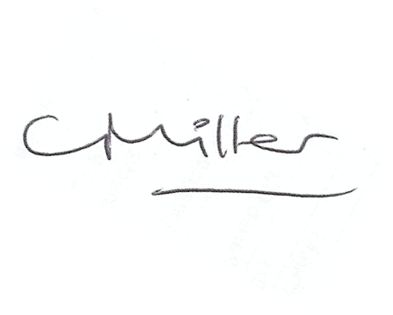
Claire Miller
Parish Clerk

www.parish-council.com/edlingham/links.asp

