Minutes of ordinary meeting of Edlingham Parish Council held at Thrunton Fishery on Wednesday 21st August 2019 commencing at 8pm
Those present: Cllr C Blythe (Chairman), Cllr R Robson, Cllr N Hargreaves, Cllr T Drummond, C Miller (Clerk)

2019/29 Apologies for Absence
Cllr’s G Herdman, J Herdman, County Cllr W Pattison

2019/30 Declaration of Interests
There were no Declaration of Interests.

2019/31 County Cllr Update
County Council to renew Edlingham church path which had been partially washed away with flood water, and improved church parking being investigated.

2019/32 Minutes of previous meeting held 22nd May 2019
The minutes of the previous meeting held 22nd May 2019 were accepted as a true record.

2019/33 Matters arising from previous meeting held 22nd May 2019
- Broadband cables had been installed within the parish.
- Comments regarding Lemmington Bank to Battle Bridge requiring resurfacing; pothole at Thrunton junction with problems exacerbated due to poor drainage; poor road surface on B6341 below Moor House, particularly on West End; and road at top of Corby Bank and Lemmington had been forwarded to G Sanderson, County Cllr and G Bucknall, Head of Highways, with comments received works could only be carried out if areas deemed highest priority.

2019/34 Planning
2019/34/01 Planning Applications received:
- 19/01932/LBC: The Stables, 1 Lemmington Hall, Listed Building Consent for new glazed opening to existing arch.
2019/34/02 Approval of Planning Application received
- 19/00664/FUL: 4 Overthwarts Farm, Swinhope Cottage, erection of 3m x 3m summerhouse in corner of front garden.
- 19/01932/LBC: The Stables, 1 Lemmington Hall, Listed Building Consent for new glazed opening to existing arch.

2019/35 Correspondence
- CPRE newsletter
- Northumberland Age UK – fund raising events
- Hospicecare North Northumberland – Fund raising events
- Northumberland County Council – Waste leaflets & stickers

2019/36 Finance
2019/36/01 The following payments are to be authorised:
- Northumberland County Council – annual insurance premium - £175.07

It was resolved to approve the payment.

2019/37 Neighbourhood Management
It was agreed to report problems with ragwort on verges throughout the parish to County Council.

2019/38 Local Transport Plan Programme 2020-21
Priorities for 2019/20 had been speed restriction at Moor House crossroads – County Council had stated this was a Primary Route with only a handful of properties at the junction and there are many crossroads similar to the location on the A697.
Road warning signage and safety improvements A697 near to Thrunton fishery – County Council had stated in 2015/16 all signs and markings had been upgraded, vegetation cut back to open up the area, drainage issue resolved and marker posts installed around the bend at 25m centres – 50m on the approach to the bend. Resurfacing of road into Thrunton – this issue had been recorded, would be considered when developing future planned maintenance programmes and monitored with any minor works carried out to maintain in a safe condition. It was agreed to retain road resurfacing at Thrunton, tree cutting from Moor House crossroads to Edlingham, traffic calming at Jockey’s Bridge on Bridge of Aln to Garmitedge road as 2020-2021 requests.

2019/39 Edlingham Community Association
Fund raising event held; plans for church extension and upgrade had been submitted to church planning authority and which would then be submitted to County Council planning department; funds for space heaters and CCTV secured; quiz to be held 31/8/19; temporary W/C in place.

2019/40 Urgent Business
There was no urgent business.

2019/41 Date of Next Meeting
The next meeting of Edlingham Parish Council will be held on Tuesday 19th November 2019 commencing 730pm at Thrunton Fishery.

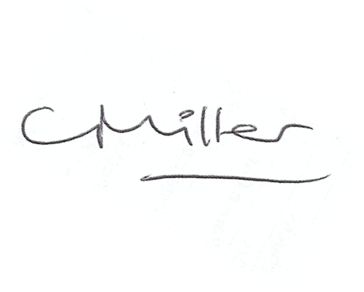
Claire Miller
Parish Clerk

The meeting closed at 830pm

www.parish-council.com/edlingham/links.asp

