Minutes of ordinary meeting of Edlingham Parish Council held at Thrunton Fishery on Monday 2nd December 2019 commencing at 730pm
Those present: Cllr C Blythe (Chairman), Cllr R Robson, Cllr N Hargreaves, Cllr J Herdman, Cllr G Herdman, Cllr T Drummond C Miller (Clerk), W Pattison (County Cllr)

2019/42 Apologies for Absence
A Hall, F Manners

2019/43 Declaration of Interests
There were no Declaration of Interests.

2019/44 County Cllr Update
Car parking for Edlingham had been placed on County Council Local Transport Plan 2020-2021. Neighbourhood consultation would be advantageous at a later date, or the Parish Council could post information to all properties within Edlingham with details of the project. Broadband for rural communities ongoing. Road to Thrunton still problematic due to potholes, and it was agreed to contact P Jones, Service Director Local Services County Council, by a formal letter, and include, once again, the road at top of Lemmington bank. Cllr N Hargreaves asked if anything could be done about four by four vehicles racing on right of ways near to Lemmington Hil – problematic areas to be confirmed, with County Cllr and Parish Council to then contact Rights of Way Officer, County Council. County Cllr suggested police officer be invited to the next Parish Council meeting.

2019/45 Minutes of previous meeting held 21st August 2019
The minutes of the previous meeting held 21st August 2019 were accepted as a true record.

2019/46 Matters arising from previous meeting held 21st August 2019
There were no matters arising from the previous meeting held 21st August 2019.

2019/47 Planning
2019/47/01 Planning Applications received:
- 19/04505/LBC: Former Coach House and Kennels, Lemmington Hall – Listed Building Consent for air source heat pump and solar panels – no objections.
2019/47/02 Approval of Planning Application received
- 19/00664/FUL: 4 Overthwarts Farm, Swinhope Cottage, erection of 3m x 3m summerhouse in corner of front garden.
- 19/03842/VARYCO; Station Cottage, The Old Station Track, Variation of Condition 2 to 18/04518/FUL in order to substitute plans.

Concern had been raised about the way the Lemmington Hall planning application, which had been rejected by previous administration at County Hall, had been passed by the present administration. Parish Council had historically objected to the application on road safety issues - County Cllr to seek further information.

2019/48 Correspondence
- CPRE newsletter.

2019/49 Finance
2019/49/01 To approve precept requirement 2020-2021
The latest financial statements and budget for 2020-2021 were accepted, and it was resolved the precept be retained at the current level of £700.

2019/50 Neighbourhood Management
2019/50/01 To discuss and approve request to place seat within the parish
Request had been received for a memorial seat at Corby Crags, and it was agreed this should not affect car parking in the area, the donee would need to maintain it, and Parish Council would take no future responsibility for the structure.

Wildlife and Countryside Act 1981, Definitive Map Modification Order (No 17) Byway Open to All Traffic No 30:
The Parish Council had no objections to this.

2019/51 Edlingham Community Association
Planning permission ongoing for church extension; progress made on flooding; quiz night held; portaloo and space heaters in place.

2019/52 Urgent Business
There was no urgent business.

2019/53 Date of Next Meeting
The next meeting of Edlingham Parish Council will be held on Monday 24th February 2019 commencing 730pm in Thrunton Long Crag Fishery.
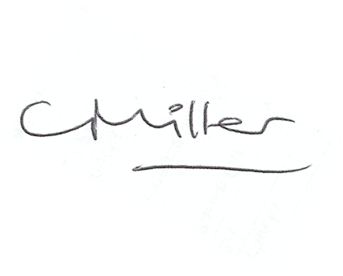
Claire Miller
Parish Clerk

The meeting closed at 830pm

www.parish-council.com/edlingham/links.asp

