Minutes of meeting of Edlingham Parish Council held at Thrunton Fishery on Tuesday 12th February 2019 commencing at 730pm
Those present: Cllr C Blythe (Chairman), Cllr T Drummond, Cllr J Herdman, Cllr A Hall, C Miller (Clerk)

2019/01 Apologies for Absence
Cllr’s N Hargreaves, R Robson, G Herdman, County Cllr W Pattison

2019/02 Declaration of Interests
There were no Declaration of Interests.

2019/03 County Cllr Update
County Council wishing to recruit professional foster parents; next Longhoughton Ward meeting to be held 12/4/19 at Alnwick Youth Hostel commencing 630pm.

2019/04 Minutes of previous meeting held 20th November 2018
The minutes of the previous meeting held 20th November 2018 were agreed as a true record.

2019/05 Matters arising from previous meeting held 20th November 2018
There were no matters arising from the previous meeting held 20th November 2018.

2019/06 Planning
2019/06/01 Planning Applications received
No planning applications had been received.

2019/06/02 Approval of Planning Application received
No approval of planning application had been received.

2019/07 Correspondence
- Confirmation of payscales from 1/4/19 – resulting in increase in Clerk salary of £9.15/annum
- Northumberland Draft Local Plan – Consultation on the soundness of the plan - 30/1 to 13/3/19
- CPRE newsletter

2019/08 Finance
2019/08/01 The following payments were authorised:
- C Miller – annual salary and expenses - £361.52
- HMRC – PAYE on above - £70.00

2019/08/02 Grant request received
- Alnwick’s Bailiffgate Museum & Gallery – no donation given.

2019/09 Neighbourhood Management
- Certain parishioners cannot receive broadband; wiring works currently being carried out within the parish and Alncom providing satellite services, however this requires a clear sightline; Titlington Mount about ready to go live; registered business’s receive full grant of £2500 towards the cost of installation and householders receive a grant of £350, with total cost being £500.
- Issues with quad bikes accessing farming land, Northumbria Police farmwatch have had a purge on such behavior and problems should be reported through this system.
- Road at top of Sandy Bank to Lemmington Crossroads requires maintenance, with vehicles having to veer into the middle of the road – Clerk to report to County Council.
- Potholes on road to Lemmington Hall – Cllr A Hall to report to County Council.

2019/10 Edlingham Community Association
Camping in the church taking place with Church permission.

2019/11 Review of internal controls/internal auditor/asset register/risk assessment and insurance cover
It was agreed the current system of internal control was adequate for the present needs of the Parish Council; Clerk to arrange internal audit to be carried out by retired Parish Clerk; noticeboad listed on asset register and approved; risk assessment approved; insurance cover currently through the County Council with standard cover for Parish Council’s and agreed as acceptable for the current needs of the Parish Council.

2019/12 Urgent Business
There was no urgent business.

2019/13 Date of Next Meeting
The next meeting of Edlingham Parish Council will be held on Wednesday 22nd May 2019 commencing after the Annual Meeting of Edlingham Parish at 8pm.

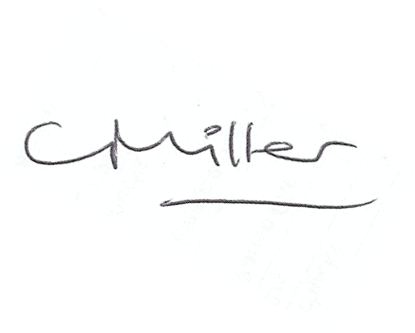
Claire Miller
Parish Clerk

The meeting closed at 805pm.

www.parish-council.com/edlingham/links.asp

