BAVINGTON PARISH COUNCIL
AGENDA PAPER
You are hereby summoned to attend a meeting of Bavington Parish Council to be held on Thursday 10th November 2016, commencing 7pm at Great Bavington Church Hall, for the purpose of transacting the business contained within this Agenda
2016/30 Apologies for Absence

2016/31 Disclosure of interests by members regarding agenda items
Members are invited to disclose any Disclosable Pecuniary Interests or other personal interests they may have in any of the items of business on the agenda in accordance with the Code of Conduct.

2016/32 Approval of minutes taken at the meeting held 4th August 2016

2016/33 Matters arising from meeting held 4th August 2016

2016/34 Election of Vice Chairman

2016/35 Correspondence
- Northumberland County Council – changes to waste recycling centre opening days
- Tynedale Hospice at Home – newsletter

2016/36 Finance
2016/36/01 Invoices payable
- Great Bavington United Reformed Church - £100 – rent of meeting room y/e 31/3/17
- To agree donation to Tynedale Hospice
- To agree donation to Great North Air Ambulance
- To agree donation to Community Action Northumberland
2016/36/02 Audit of Accounts 2015-2016
2016/36/03 Set precept 2017-2018
2016/36/04 To discuss becoming members of Northumberland and Newcastle Society

2016/37 Planning
2016/37/01 Planning Applications
- 16/02941/FUL: Mr & Mrs Acton, Plashetts Farm - single storey extension to front of farmhouse to form entrance porch
- 16/03666/FUL: Mrs C Hogg, Bavington Mount, Capheaton – change of use of existing buildings to residential use and construction of extension on part of footprint of existing shed.
2016/37/02 Any other Planning Matters

2016/38 Ray Wind Farm/Broadband Update
2016/39 Parish Council Web-site
2016/40 Any other Business

2016/41 Date of Next Meeting
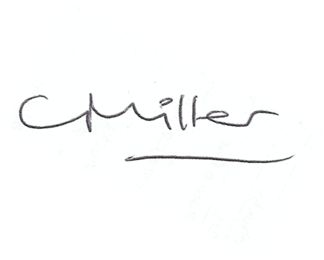
Dated this 7th day of November 2016.
Claire Miller
Parish Clerk

