BAVINGTON PARISH COUNCIL
AGENDA PAPER
You are hereby summoned to attend a meeting of Bavington Parish Council to be held on Thursday 3rd August 2017, commencing 6pm at Ladywell, Great Bavington, for the purpose of transacting the business contained within this Agenda
2017/25 Apologies for Absence

2017/26 Disclosure of interests by members regarding agenda items
Members are invited to disclose any Disclosable Pecuniary Interests or other personal interests they may have in any of the items of business on the agenda in accordance with the Code of Conduct.

2017/27 Meeting with Donald Wilkins to discuss future development of Divet Hill quarry

2017/28 Approval of minutes taken at the meeting held 19th May 2017

2017/29 Ray Farm Community Fund representative/Ray Wind Farm Update

2017/30 Matters arising from meeting held 19th May 2017
- Request for Grit Bins: Confirmation areas do not score high enough to qualify for a bin, however PC can purchase and fund through County Council.

2017/31 Correspondence
- City and County – newsletter
- Northumberland County Council – cattle grids and grid bins
- Northumberland County Council – The Green Dog Walkers Responsible Dog Ownership Campaign
- Fire and Rescue Service – Plan 2017 – 2021
- County Council – LTP 2018 – 19 – to agree/discuss priorities

2017/32 Finance
2017/32/01 Invoices payable

2017/33 Planning
2017/33/01 Approval of Planning Applications received: 17/00784/FUL, Mr & Mrs Carr, Little Bavington Farm, construction of three bedroom detached far workers dwelling with detached garage and workshop building
2017/33/02 Northumberland Local Plan Core Strategy – withdrawal from Examination

2017/34 Localism Bill
2017/35 Parish Council Web-site
2017/36 Any other Business

2017/37 Date of Next Meeting
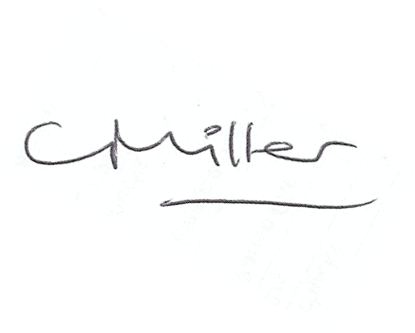
Dated this 26th day of July 2017
Claire Miller
Parish Clerk

