BAVINGTON PARISH COUNCIL
AGENDA PAPER
You are hereby summoned to attend a meeting of Bavington Parish Council to be held on Thursday 1st November 2018 commencing 7pm at Great Bavington URC Church meeting room, for the purpose of transacting the business contained within this Agenda
2018/46 Apologies for Absence
2018/47 Disclosure of interests by members regarding agenda items
Members are invited to disclose any Disclosable Pecuniary Interests or other personal interests they may have in any of the items of business on the agenda in accordance with the Code of Conduct.
2018/48 Approval of minutes taken at the meeting held 9th August 2018
2018/49 Matters arising from meeting held 9th August 2018
2018/50 Ray Wind Farm Fund Update
2018/50/01 Ash Trees
2018/51 Correspondence
- City and County – Northumberland & Newcastle Society newsletter; CPRE - newsletter
2018/52 Finance
2018/52/01 To authorise payments: Great Bavington URC - £100 – meeting room
2018/52/02 To authorise grants to the following: Great North Air Ambulance; Tynedale Hospice; St Aidan’s Thockrington; Community Action Northumberland
2018/52/03 To approve precept 2019-2020
2018/53 Planning
2018/53/01 Planning Applications received:
- 18/03005/OHL: Northern Powergrid, remove and replace 13 spans of existing overhead lines, land South West of Great Bavington towards Newtonstead, Kirkharle
- 18/03508/FUL: Land South East of Homilton Farm, Colwell – proposed crop store and sheep shed
2018/53/02 Approval of Planning Application received:
- 18/00734/FUL: Steel Rigg Farm – proposed change of use of part of an existing equestrian paddock by constructing a menage/outdoor arena for personal use
- 18/01998/FUL: Land North of Steel Rigg Cottage – conversion of agricultural shed to single dwelling
- 18/03005/OHL: Northern Powergrid, remove and replace 13 spans of existing overhead lines, land South West of Great Bavington towards Newtonstead, Kirkharle
2018/54 Noise Complaint, Divet Hill Quarry
2018/55 Dangerous bend, B6342 Little Bavington
2018/56 Renewal of Great Bavington interpretation panel
2018/57 Any other Business
2018/58 Date of Next Meeting
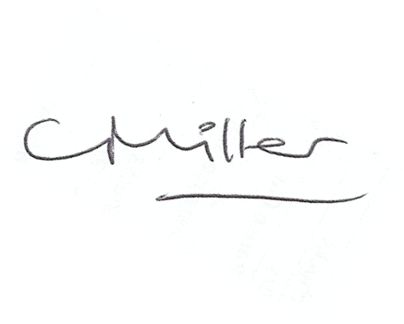
Dated this 23rd day of October 2018
Claire Miller
Parish Clerk

