BAVINGTON PARISH COUNCIL
AGENDA PAPER
You are hereby summoned to attend a meeting of Bavington Parish Council to be held on Thursday 1st February 2018, commencing 7pm at Great Bavington URC Church meeting room, for the purpose of transacting the business contained within this Agenda
2018/01 Apologies for Absence
2018/02 Disclosure of interests by members regarding agenda items
Members are invited to disclose any Disclosable Pecuniary Interests or other personal interests they may have in any of the items of business on the agenda in accordance with the Code of Conduct.
2018/03 Election of Chairman and Election of Vice Chairman
2018/04 Co-Option Vacancy
2018/05 Approval of minutes taken at the meeting held 2nd November 2017
2018/06 Matters arising from meeting held 2nd November 2017
- Grit Bin

2018/07 Ray Wind Farm Fund Update
2018/08 Correspondence
- CPRE – newsletter
- Northumberland & Newcastle Society – City and County newsletter

2018/09 Finance
2018/09/01 To authorise the following payments:
- C Miller, annual salary and expenses (including reimbursement of new noticeboard at £148) - £744.01
- HMRC – PAYE on above - £121.00
- Northumberland County Council – supply of grit bin and 2 refills - £240
2018/09/02 Donation acknowledgement’s received
- Community Action Northumberland; Great North Air Ambulance
- Hospice at Home
- Gynae-Oncology Fund at the Freeman Hospital
2018/09/03 Request for Grant had been received from the following:
- Sport Tynedale

2018/10 Planning
2018/10/01 Planning Applications received:
- 17/04202/FUL: Mr & Mrs Hickson, Homilton Farm B6342 Throckrington Junction to Shiel Hill – construction of single storey rear extension AND APPROVED
- 17/04633/VARYCCM and 17/04637/VARCCM – Divet Hill Quarry – Variation of condition 7 and variation of condition 1
2018/11 Problems with television signal and mobile phone coverage within the parish
2018/12 Dangerous bend, B6342 Little Bavington
2018/13 Any other Business
2018/14 Date of Next Meeting
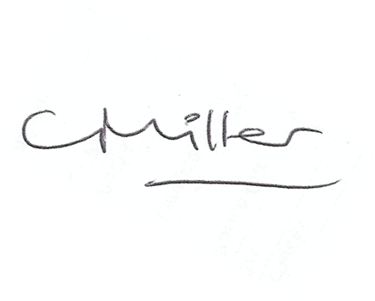
Dated this 22nd day of January 2018
Claire Miller
Parish Clerk

