BAVINGTON PARISH COUNCIL
AGENDA PAPER
You are hereby summoned to attend a meeting of Bavington Parish Council to be held on Thursday 3rd May 2018 after the Annual Parish Meeting commencing 7pm at Great Bavington URC Church meeting room, for the purpose of transacting the business contained within this Agenda
2018/15 Apologies for Absence
2018/16 Disclosure of interests by members regarding agenda items
Members are invited to disclose any Disclosable Pecuniary Interests or other personal interests they may have in any of the items of business on the agenda in accordance with the Code of Conduct.
2018/17 Election of Chairman and Election of Vice Chairman
2018/18 Approval of minutes taken at the meeting held 1st February 2018
2018/19 Matters arising from meeting held 1st February 2018
2018/20 Ray Wind Farm Fund Update
2018/21 Correspondence
- City and County newsletter
- Northumberland County Council, Love Northumberland Awards 2018
- Northumberland County Council, recycling
- Northumberland County Council, weed control
- Northumberland County Council, road hierarchy consultation

2018/22 Finance
2018/22/01 To authorise the following payments:
- Annual insurance premium – Came and Company - £218.00.
2018/22/02 To receive grant request from Northumberland Citizens Advice
2018/23 Audit of Accounts year ending 31/3/18
2018/23/01 To review the effectiveness of the system of internal control and consider the findings
2018/23/02 To consider and agree any actions arising from the report of the internal auditor
2018/23/03 To approve the draft annual accounts for 2017/2018
2018/23/04 To approve the Accounting Statement and explanation of variances
2018/23/05 To confirm and approve the Certificate of Exemption
2018/24 Planning
2018/24/01 Planning Applications received:
- 18/00639/FUL: Mr I Hamilton, land north of Steel Rigg Cottage, Capheaton – general purpose steel portal framed building AND APPROVED.
- 18/00763/FUL: Mr S Robinson, land north of Steel Rigg Cottage, conversion of an existing steel framed agricultural shed to a single dwelling
- 18/00606/FUL: Mr E Hickson, Homilton Farm, Capheaton – portal framed cattle shed to provide modern livestock housing facilities
2018/25 Problems with television signal and mobile phone coverage within the parish
2018/26 Dangerous bend, B6342 Little Bavington
2018/27 To receive/discuss information/action plan relating to General Data Protection Regulations (GDPR)
2018/28 Wildlife and Countryside Act 1981, Parish of Bavington Byway No 28
2018/29 Any other Business
2018/30 Date of Next Meeting
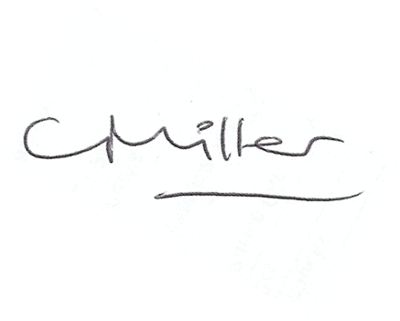
Dated this 24th day of April 2018
Claire Miller
Parish Clerk

