BAVINGTON PARISH COUNCIL
AGENDA PAPER
You are hereby summoned to attend an ordinary meeting of Bavington Parish Council to be held on Thursday 8th August 2019 commencing at 7pm at Great Bavington URC Church meeting room, for the purpose of transacting the business contained within this Agenda
2019/32 Apologies for Absence
2019/33 Disclosure of interests by members regarding agenda items
Members are invited to disclose any Disclosable Pecuniary Interests or other personal interests they may have in any of the items of business on the agenda in accordance with the Code of Conduct.

2019/34 Approval of minutes taken at the meeting held 1st May 2019
2019/35 Matters arising from meeting held 1st May 2019
2019/36 Ray Wind Farm Fund Update
2019/37 Correspondence
- Tynedale Hospice at Home newsletter
- CPRE newsletter
- Northumberland Age UK
2019/38 Finance
2019/38/01 To authorise payments
2019/39 Planning
2019/39/01 Planning Applications received
2019/39/02 Approval of Planning Application received:
- 17/04633/VARCCM: Divet Hill Quarry, variations of conditions of 07/00160/CCMEIA
- 17/04637/VARCCM: Divet Hill Quarry, variation of conditions of 16/04140/VARYCO
- 19/00876/FUL & 19/00877/LBC: Land at West of Bavington Hall, change of use of tearoom/shop to dwelling
- 19/01578/FUL: Newonstead Cottage, construction of single storey side extension to create new porch, utility and bathroom
2019/40 Noise Complaint, Divet Hill Quarry
2019/41 Dangerous bend, B6342 Little Bavington
2019/42 Renewal of Great Bavington interpretation panel
2019/43 Local Transport Plan Programme 2020-21
2019/44 Any other Business
2019/45 Date of Next Meeting
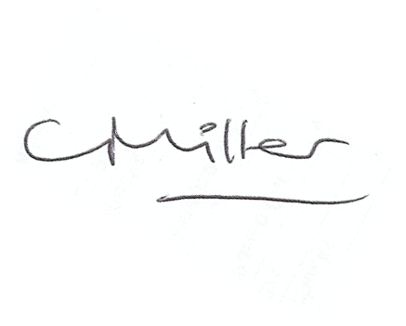
Dated this 29th day of July 2019

Claire Miller
Parish Clerk

