BAVINGTON PARISH COUNCIL
Minutes of meeting of Bavington Parish Council held on Thursday 4th February 2016, commencing 7pm at Great Bavington Church Hall,
Those Present: Richard Taylor (Deputy Chairman), Nicola Bell, Peter Ramsden, Peter Action, Catherine Hogg,
John Spearman, John Riddle (NCC)

2016/01 Apologies for Absence
Carol Brodie

2016/02 Disclosure of interests by members regarding agenda items
Members are invited to disclose any Disclosable Pecuniary Interests or other personal interests they may have in any of the items of business on the agenda in accordance with the Code of Conduct.

2016/03 Approval of minutes taken at the meeting held 12th November 2015
The minutes of the previous meeting were agreed as a true record after minor amendments.

2016/04 Matters arising from meeting held 12th November 2015
- Nicola Bell had unsuccessfully attempted to secure financial figure for Green Rigg Community Fund.
- Church had carried out survey of the parish with Clerk’s email address included for interested parties to receive updates and one person having shown interest. It was agreed to ask parishioners if they wish to sign up to e-newsletters at the next film night.
- Details of how to access and update web-site to be provided to clerk, with Catherine Hogg’s email needing to be amended.
- CAN advertising for new Chief Executive to replace David Francis.

2016/05 Correspondence
- Request for Donation - Northumberland Community Voluntary Action – RPC currently subscribes to similar organisations, such as NALC, however the group can assist, for a fee, with specialist issues, such as neighbourhood planning, should the need arise, therefore no donation given.
- Northumberland County Council – Street lighting modernisation – not applicable to this parish.
- Northumberland County Council – Community regeneration team.
- Northumberland County Council – Winter services .
- Thockrington PCC – donation thanks.
- Great North Air Ambulance – donation thanks.
- Tynedale Hospice – donation thanks.

2016/06 Finance
2016/06/02 Invoices authorised
- C Miller – annual salary & expenses - £504.74
- HMRC – PAYE on above - £108.20

2016/06/03 Other Financial Matters
There were no other financial matters.

2016/07 Planning
2016/07/01 Planning Applications
No planning applications received. NCC J Riddle advised 99% of planning applications are now delegated to officers, with several Parish Council’s making objection to the new process.

2016/07/02 Neighbourhood Plan
Nothing to report.
2016/07/03 Any other Planning Matters
There were no further planning matters.

2016/08 Any other Business
- Peter Ramsden reported on information from latest Know Northumberland newsletter; with crime rates low compared to rest of country; information on average house prices; small immigrant community; population age statistics; birth rate statistics; smoking related deaths reducing swiftly with 16% of Northumberland adults smokers; however there are now more binge drinkers in Northumberland than rest of the North-East.
- Catherine Hogg reported trees encroaching onto highway from Little Bavington to Hallington, Chris Westerby, Area Manager at Hexham to be contacted and to also report trees encroaching on c road at Junction B6342, towards Great Bavington.
- Pothole problems ongoing, highway inspectors should be reporting on such matters. Catherine Hogg had previously reported several problems which had been quickly rectified.
- John Riddle reported NCC having to save 95million next financial year, with proposed new headquarters at Ashington to cost at least 45million. Several public W/C’s had been closed, however parts of the budget are ringfenced, such as social services and education. Issues concerning capital and revenue expenditure, which appears to be political. Special funds had been received for flood damage, with funds for forestry being pushed as when trees planted, removal of the timber had not been well thought out and is now causing problems. Changes to school transport due to Snaith Travel court case, however company would be able to re-tender in as little as a year. Farm water risk assessments briefly discussed.

2016/09 Date of Next Meeting
The next meeting of Bavington Parish Council will be held on Thursday 5th May 2016 commencing after the Annual Meeting of the Parish of Bavington.
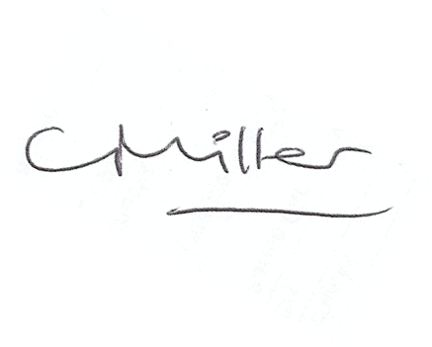
Claire Miller
Parish Clerk

