Minutes of extraordinary electronic meeting of Bavington Parish Council held on Monday 7th December commencing at 6pm
Those Present: P Acton (Chairman), P Ramsden, L Robson, R Taylor, seven members of the public

2020/EXTRAORDINARY/01 Apologies for Absence
J Spearman, C Hogg

2020/EXTRAORDINARY/02 Disclosure of interests by members regarding agenda items
There were no Declaration of Interests.

2020/EXTRAORDINARY/03 To consider Planning Applications received relating to Divet Hill Quarry
- 20/03660/CCMEIA: Divet Hill Quarry – Lateral extension to north of existing quarry boundary for the phased extraction of approximately 2.7 million tonnes of whinstone and restoration of site to agricultural grassland and nature conservation uses. P Ramsden had drafted Parish Council objection to the proposals as follows:
“This proposal if allowed would bring quarrying operations very close to the Conservation Area of Great Bavington as well as to other local households. The Council believe this would result in excess noise, both in relation to blasting and subsequent quarry operations. There would be an unacceptable risk of dust and significant adverse impact on the setting of the Conservation Area. It is the Council view that the local community have lived with the Quarry over a number of years but this proposal represents a threat on a different scale to any previous planning application by the Quarry. The Parish Council are unanimous in rejecting this proposal for the reasons outlined. We would be grateful if you could carry this view forward in the determination of the application.”
There is clear agreement the community are against the proposals.

- 20/03661/VARCCM: Divet Hill Quarry – Variation of conditions 1 to 17/04637/VARCCM to extend the duration of consented operations, amend the approved documentation associated with the operation and amend the noise limits applicable to the operation: An increase in noise limits and working hours had been requested with a 2 decibel noise increase, the current limit being 42 decibels at Little Bavington. Parishioner had concerns about the proximity of 250m of the proposed site to the conservation area. It was resolved P Ramsden would draft a further short direct objection to the noise issues to be circulated to all Cllr’s for authorisation.

The deadline date for submission was 10th December, however a little leeway could be given on this.

2020/EXTRAORDINARY/04 Date of Next Meeting
The next meeting of Bavington Parish Council will be held on Thursday 4th February 2021 commencing 7pm.

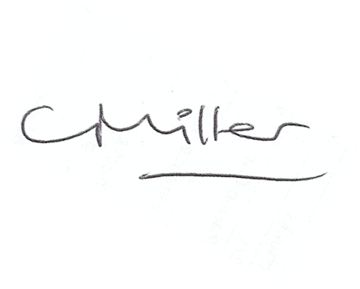
Claire Miller
Parish Clerk

The meeting closed at 630pm.

