BAVINGTON PARISH COUNCIL
AGENDA PAPER
You are hereby summoned to attend a meeting of Bavington Parish Council to be held on Thursday 4th August 2016, commencing 7pm at Great Bavington Church Hall, for the purpose of transacting the business contained within this Agenda
2016/21 Apologies for Absence

2016/22 Disclosure of interests by members regarding agenda items
Members are invited to disclose any Disclosable Pecuniary Interests or other personal interests they may have in any of the items of business on the agenda in accordance with the Code of Conduct.

2016/23 Approval of minutes taken at the meeting held 5th May 2016

2016/24 Matters arising from meeting held 5th May 2016

2016/25 Correspondence
- Northumberland County Council – Core Strategy final consultation
- Northumberland County Council – Local Transport Plan requests 2017-2018
- Whittington Parish Council – Neighbourhood Plan
- Northumberland Association of Local Councils – County Council revenue saving

2016/26 Finance
2016/26/01 Invoices payable
- Northumberland Association of Local Councils – annual subscription - £45.92
2016/26/02 Request for donation – Community Action Northumberland
2016/26/03 Audit of Accounts 2015-2016
2016/26/04 Any other financial matters

2016/27 Planning
2016/27/01 Planning Applications
2016/27/02 Any other Planning Matters

2016/28 Any other Business

2016/29 Date of Next Meeting
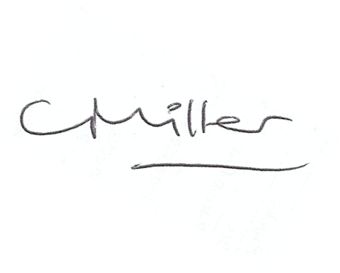
Dated this 27th day of July 2016.
Claire Miller
Parish Clerk

