BAVINGTON PARISH COUNCIL
AGENDA PAPER
You are hereby summoned to attend a meeting of Bavington Parish Council to be held on Thursday 5th May 2016, commencing 7pm at Great Bavington Church Hall, for the purpose of transacting the business contained within this Agenda
2016/10 Apologies for Absence

2016/11 Disclosure of interests by members regarding agenda items
Members are invited to disclose any Disclosable Pecuniary Interests or other personal interests they may have in any of the items of business on the agenda in accordance with the Code of Conduct.

2016/12 Approval of minutes taken at the meeting held 4th February 2016

2016/13 Matters arising from meeting held 4th February 2016

2016/14 Correspondence
- Northumberland County Council – tree clearance
- Northumberland County Council – Wildlife & Countryside Act 1981 – Definitive Map Modification Order (No 1) 2016
- Request to display advertisement for St Francis Xavier R.C. Chapel, Cheesburn Grange
- Northumberland County Council – Love Northumberland Awards 2016

2016/15 Finance
2016/15/01 Invoices payable
- Zurich – annual insurance premium - £236.98
- Hire of Great Bavington URC – notice of formal hiring arrangements at £25/meeting (£100 per annum)
2016/15/02 Audit of Accounts 2015-2016
2016/15/03 Any other financial matters

2016/16 Planning
2016/16/01 Planning Applications
2016/16/02 Neighbourhood Plan
2016/16/03 Any other Planning Matters

2016/17 Ponteland school consultation

2016/18 Risk Assessment

2016/19 Any other Business

2016/20 Date of Next Meeting
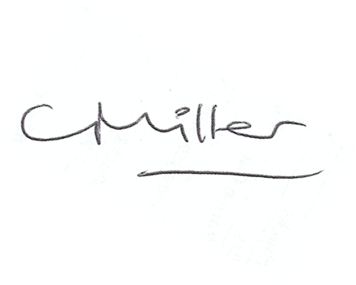
Dated this 25th day of April 2016.
Claire Miller
Parish Clerk

