BAVINGTON PARISH COUNCIL
AGENDA PAPER
You are hereby summoned to attend a meeting of Bavington Parish Council to be held on Friday 19th May 2017, commencing 615pm at Ladywell, Great Bavington, for the purpose of transacting the business contained within this Agenda
2017/12 Apologies for Absence

2017/13 Disclosure of interests by members regarding agenda items
Members are invited to disclose any Disclosable Pecuniary Interests or other personal interests they may have in any of the items of business on the agenda in accordance with the Code of Conduct.

2017/14 Meeting with Cemex regarding Divet Hill Quarry extension and restoration works

2017/15 Approval of minutes taken at the meeting held 9th February 2017

2017/16 Ray Wind Farm Update

2017/17 Matters arising from meeting held 9th February 2017
- Request for Grit Bins: Confirmation areas do not score high enough to qualify for a bin, however PC could purchase and fund through County Council.

2017/18 Correspondence
- Northumberland & Newcastle Society – newsletter
- Northumberland County Council – Wildlife & Countryside Act 1981, Definitive Map Modification Order (No 19) 2014, Byways Open to all Traffic Nos 41 & 27 (Parishes of Chollerton and Bavington) – confirmation of order
- NALC – notice of vacancies on County Committee for members of this parish

2017/19 Finance
2017/19/01 Invoices payable
- NALC – annual subscription - £46.36
- Zurich Municipal – annual insurance policy - £242.37
2017/19/02 Audit of Accounts year ending 31/3/17: to discuss and approve Annual Governance Statement and Accounting Statements year ending 31/3/17
2017/19/03 Review of Clerk’s Pay Scale

2017/20 Planning
2017/20/01 Planning Applications received:
- 17/00784/FUL: Mr & Mrs Carr, Little Bavington Farm – construction 3 bedroom detached farm workers dwelling and detached garage and workshop building and general purpose steel portal frame agricultural building

2017/21 Localism Bill: Correspondence received from Department for Communities & Local Government
2017/22 Parish Council Web-site
2017/23 Any other Business

2017/24 Date of Next Meeting
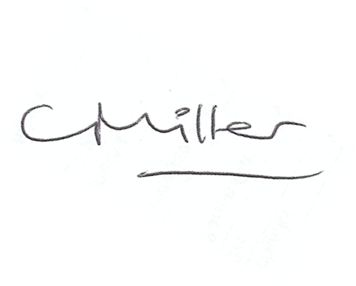
Dated this 9th day of May 2017
Claire Miller
Parish Clerk

