BAVINGTON PARISH COUNCIL
AGENDA PAPER
You are hereby summoned to attend a meeting of Bavington Parish Council to be held on Thursday 2nd November 2017, commencing 7pm at Great Bavington URC Church meeting room, for the purpose of transacting the business contained within this Agenda
2017/38 Apologies for Absence
2017/39 Disclosure of interests by members regarding agenda items
Members are invited to disclose any Disclosable Pecuniary Interests or other personal interests they may have in any of the items of business on the agenda in accordance with the Code of Conduct.
2017/40 Vacancy
2017/41 Election of Chairman and Election of Vice Chairman
2017/42 Approval of minutes taken at the meeting held 3rd August 2017
2017/43 Ray Wind Farm Update
2017/44 Matters arising from meeting held 3rd August 2017
- Grit Bin
2017/45 Correspondence
- Northumberland and Newcastle Society newsletter
- Northumberland County Council – LTP, information regarding requests
- Guy Opperman, Community Champion
- Northumberland County Council – Bus timetables
- Northumberland County Council – consultation on Northumberland Area Special Education Needs School Place Planning Strategy
2017/46 Finance
2017/46/01 To authorise the following payments:
- Great Bavington United Reformed Church - £100 – rent of meeting room y/e 31/3/18
2017/46/02 To discuss/agree grants to the following
- Tynedale Hospice
- St Aidan’s Thockrington
- Great North Air Ambulance
- Community Action Northumberland
2017/46/03 To discuss/agree quotations received for noticeboard at Great and Little Bavington
2017/46/04 To discuss/agree precept 2018 - 2019

2017/47 Planning
2017/47/01 Approval of Planning Applications received: 17/00784/FUL, Mr & Mrs Carr, Little Bavington Farm, construction of three bedroom detached far workers dwelling with detached garage and workshop building
2017/48 Problems with television signal and mobile phone coverage within the parish
2017/49 Review of Parish Council Standing Orders
2017/50 Dangerous bend, B6342 Little Bavington
2017/51 Any other Business
2017/52 Date of Next Meeting
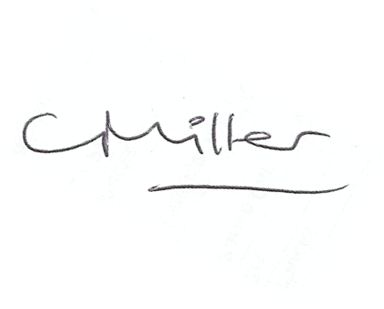
Dated this 23rd day of October 2017
Claire Miller
Parish Clerk

