BAVINGTON PARISH COUNCIL
AGENDA PAPER
You are hereby summoned to attend a meeting of Bavington Parish Council to be held on Thursday 9th August 2018 commencing 7pm at Great Bavington URC Church meeting room, for the purpose of transacting the business contained within this Agenda
2018/31 Apologies for Absence
2018/32 Disclosure of interests by members regarding agenda items
Members are invited to disclose any Disclosable Pecuniary Interests or other personal interests they may have in any of the items of business on the agenda in accordance with the Code of Conduct.
2018/33 Approval of minutes taken at the meeting held 3rd May 2018
2018/34 Matters arising from meeting held 3rd May 2018
2018/35 Ray Wind Farm Fund Update
2018/36 Correspondence: CPRE – newsletter; County Council – disposing of hazardous waste; County Council – notice of Annual Town and Parish Conference 11/10/18

2018/37 Finance
2018/37/01 To authorise the following payment:
- NALC – annual subscription - £47.74

2018/38 Planning
2018/38/01 Planning Applications received:
- 18/00734/FUL: Steel Rigg Farm, proposed change of use of part of an existing equestrian paddock by constructing a menage/outdoor arena for personal use
- 18/01624/VARYCO: Bavington Mount – variation of condition 2 (approved plans) pursuant to planning application 16/03666/FUL in order to alter plans to include new steel beam detail
- Land north of Steel Rigg Cottage – conversion of existing steel framed agricultural shed to a single dwelling
2018/38/02 Approval of Planning Application received:
- 18/00606/FUL: Homilton Farm, Capheaton – cattle shed
- 18/01624/VARYCO: Bavington Mount – variation of condition 2 (approved plans) pursuant to planning application
2018/38/03 Northumberland Local Plan Consultation

2018/39 Dangerous bend, B6342 Little Bavington
2018/40 Local Transport Plan feedback 2018-19/Approve submission 2019-20
2018/41 Adoption of documents relating to General Data Protection Regulations (GDPR)
2018/42 Renewal of Great Bavington interpretation panel
2018/43 Feedback from pubic meeting 24/7/18
2018/44 Any other Business
2018/45 Date of Next Meeting
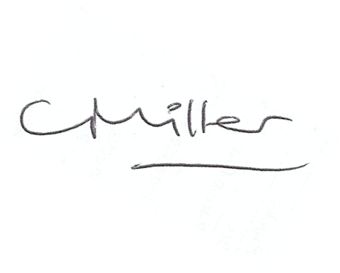
Dated this 31st day of July 2018
Claire Miller
Parish Clerk

