BAVINGTON PARISH COUNCIL
AGENDA PAPER
You are hereby summoned to attend a meeting of Bavington Parish Council to be held on Thursday 7th February 2019 commencing 7pm at Great Bavington URC Church meeting room, for the purpose of transacting the business contained within this Agenda
2019/01 Apologies for Absence
2019/02 Disclosure of interests by members regarding agenda items
Members are invited to disclose any Disclosable Pecuniary Interests or other personal interests they may have in any of the items of business on the agenda in accordance with the Code of Conduct.
2019/03 Approval of minutes taken at the meeting held 1st November 2018
2019/04 Matters arising from meeting held 1st November 2018
2019/05 Ray Wind Farm Fund Update
2019/06 Correspondence
- Grant acknowledgement received from Great North Air Ambulance
- City and County newsletter
- Confirmation of NJC payscales from 1/4/19
- Northumberland County Council – Roadside litter campaign 2018
- Northumberland Draft Local Plan – Consultation 30/1 to 13/3/19
- CPRE newsletter
2019/07 Finance
2019/07/01 To authorise payments:
- C Miller, annual salary and expenses - £615.97
- HMRC – PAYE on above - £123.60
- Northumberland & Newcastle Society – annual membership - £30.00
2019/07/02 Acknowledgement of grants: Thockrington Church; Great North Air Ambulance; Tynedale Hospice
2019/07/03 To approve changes to bank account and signatories to allow on-line banking
2019/08 Planning
2019/08/01 Planning Applications received:
- 18/04184/FUL: LandEast of Cocklaw Walls, proposed extension to steel portal framed farm building
- 19/00044/PREAPP: Steel Rigg Farm Belsay – pre-application to construct a timber barn and stable block
2019/08/02 Approval of Planning Application received:
- 1803508/FUL: Land South East of Homilton Farm – proposed crop store and sheep shed
2019/09 Noise Complaint, Divet Hill Quarry
2019/10 Dangerous bend, B6342 Little Bavington
2019/11 Renewal of Great Bavington interpretation panel
2019/12 Wildlife & Countryside Act 1981, Review of the Definitive Map and Statement of Public Rights of Way, Application for Modification Order: Bavington to Newonstead
2019/13 Review of internal controls/internal auditor/asset register/risk assessment and insurance cover

2019/14 Any other Business
2019/15 Date of Next Meeting
Clerk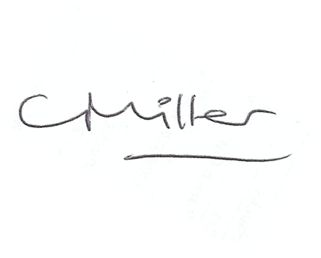
Dated this 29th day of January 2019
Claire Miller
Parish Clerk

