BAVINGTON PARISH COUNCIL
AGENDA PAPER
You are hereby summoned to attend a meeting of Bavington Parish Council to be held on Thursday 2nd May 2019 commencing after the Annual Parish meeting at 7pm at Great Bavington URC Church meeting room, for the purpose of transacting the business contained within this Agenda
2019/16 Apologies for Absence
2019/17 Disclosure of interests by members regarding agenda items
Members are invited to disclose any Disclosable Pecuniary Interests or other personal interests they may have in any of the items of business on the agenda in accordance with the Code of Conduct.

2019/18 Election of Chairman
2019/19 Election of Vice Chairman
2019/20 Approval of minutes taken at the meeting held 7th February 2019
2019/21 Matters arising from meeting held 7th February 2019
2019/22 Ray Wind Farm Fund Update: Feasibility study regarding engaging youths
2019/23 Correspondence
2019/24 Finance
2019/24/01 To authorise payments:
- Came and Company - annual insurance premium - £218
2019/25 Planning
2019/25/01 Planning Applications received:
- 19/00876/FUL: Land at West of Bavington Hall – proposed change of use of previous tea room/shop into one bedroom holiday cottage
2019/25/02 Approval of Planning Application received:
2019/26 Noise Complaint, Divet Hill Quarry
2019/27 Dangerous bend, B6342 Little Bavington
2019/28 Renewal of Great Bavington interpretation panel

2019/29 Audit of Accounts year ending 31/3/19
2019/29/01 To consider and agree any actions arising from the report of the internal auditor
2019/29/02 To approve the Governance Statement
2019/29/03 To approve the draft annual accounts for 2018/2019
2019/29/04 To approve the Accounting Statement and explanation of variances

2019/30 Any other Business
2019/31 Date of Next Meeting
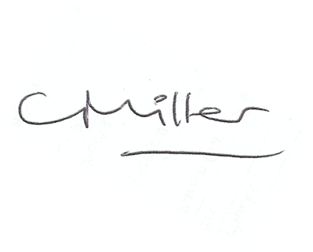
Dated this 23rd day of April 2019
Claire Miller
Parish Clerk

