BAVINGTON PARISH COUNCIL
AGENDA PAPER
You are hereby summoned to attend an ordinary meeting of Bavington Parish Council to be held on Thursday 7th November 2019 commencing at 7pm at Great Bavington URC Church meeting room, for the purpose of transacting the business contained within this Agenda
2019/46 Apologies for Absence

2019/47 Disclosure of interests by members regarding agenda items
Members are invited to disclose any Disclosable Pecuniary Interests or other personal interests they may have in any of the items of business on the agenda in accordance with the Code of Conduct.

2019/48 Co-Option Vacancy
2019/49 Meeting with Cemex regarding proposed northerly extension of Divethill Quarry
2019/50 Approval of minutes taken at the meeting held 8th August 2019
2019/51 Matters arising from meeting held 8th August 2019
2019/52 Ray Wind Farm Fund Update
2019/53 Correspondence

2019/54 Finance
2019/54/01 To discuss/authorise grants to the following: Sport Tynedale
Great North Air Ambulance; Tynedale Hospice; St Aidan’s Thockrington; Community Action Northumberland; Northumberland age UK; Citizens Advice Northumberland
2019/54/02 To approve precept 2020-20201

2019/55 Planning
2019/55/01 Planning Applications received
2019/55/02 Approval of Planning Application received:
- 19/02258/VARYCO: Land North of Steel Rigg Cottage – Variation of condition 2 to 18/01998/FUL in order to change the external material colours

2019/56 Review of Standing Orders

2019/57 Any other Business

2019/58 Date of Next Meeting
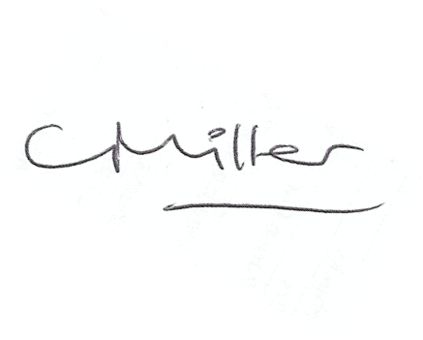
Dated this 29th day of October 2019

Claire Miller
Parish Clerk

