BAVINGTON PARISH COUNCIL
AGENDA PAPER
You are hereby summoned to attend an ordinary meeting of Bavington Parish Council to be held on Thursday 6th February 2020 commencing at 7pm at Great Bavington URC Church meeting room, for the purpose of transacting the business contained within this Agenda
2020/01 Apologies for Absence

2020/02 Disclosure of interests by members regarding agenda items
Members are invited to disclose any Disclosable Pecuniary Interests or other personal interests they may have in any of the items of business on the agenda in accordance with the Code of Conduct.

2020/03 Co-Option Vacancy
2020/04 Approval of minutes taken at the meeting held 7th November 2019
2020/05 Matters arising from meeting held 7th November 2019
- Mud on road at Thockrington corner
2020/06 Ray Wind Farm Fund Update
2020/07 Correspondence
- Grant Acknowledgement – Tynedale Hospice at Home; Great North Air Ambulance
- CPRE newsletter

2020/08 Finance
2020/08/01 To authorise payments:
- C Miller – annual salary and expenses – £600.01
- HMRC – PAYE on above - £126.80
2020/08/02 To discuss/approve grant to:
- Great Bavington United Reformed Church

2020/09 Planning
2020/09/01 Planning Applications received
2020/09/02 Approval of Planning Application received:
2020/09/03 Land South West of Homilton Farm, Capheaton
2020/10 Review of Internal Auditor and Internal Controls
2020/11 Review of Risk Assessment
2020/12 Review of Asset Register
2020/13 Review of insurance policy

2020/14 Northumberland County Council – Consultation on library services

2020/15 Any other Business

2019/16 Date of Next Meeting

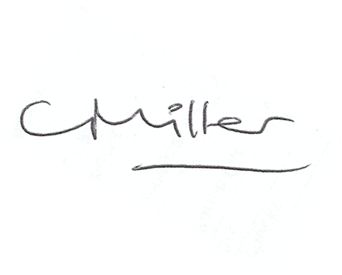
Dated this 27th day of January 2020

Claire Miller
Parish Clerk

