BAVINGTON PARISH COUNCIL

AGENDA PAPER

You are hereby summoned to attend an ordinary meeting of Bavington Parish Council to be held on Thursday 5th August 2021 commencing at 7pm in Great Bavington URC meeting room, for the purpose of transacting the business contained within this Agenda. The public are welcome to observe.

2021/30 Apologies for Absence

2021/31 Disclosure of interests by members regarding agenda items
Members are invited to disclose any Disclosable Pecuniary Interests or other personal interests they may have in any of the items of business on the agenda in accordance with the Code of Conduct.

2021/32 Approval of minutes taken at the meeting held 18th May 2021

2021/33 Matters arising from meeting held 18th May 2021

2021/34 Ray Wind Farm Fund
2021/34/01 To receive information regarding B4RN/B4NTR Broadband matters

2021/35 Finance
2021/35/01 To approve payments:

2021/36 Planning
2021/36/01 Planning Applications received
- 21/02474/FUL: Land Through North of Caverton – resubmission, proposed farm access track
2021/36/02 Approval of Planning Application received
2021/36/03 Northumberland Local Plan Examination – Consultation on Main Modifications

2021/37 To approve Local Transport Plan priorities for 2022-23

2021/38 Any other Urgent Business/Items for Next Meeting

2021/39 Date of Next Meeting

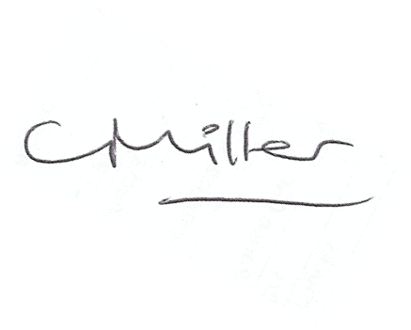
dated this 26th day of July 2021
Claire Miller, Parish Clerk

