BAVINGTON PARISH COUNCIL

AGENDA PAPER

You are hereby summoned to attend the Annual meeting of Bavington Parish Council to be held on Tuesday 18th May 2021 commencing at 7pm in Great Bavington URC Church meeting room, for the purpose of transacting the business contained within this Agenda. The public are welcome to observe.
This will be the first face to face meeting since the Covid-19 pandemic, please see Risk Assessment attached.

2021/17 Apologies for Absence
2021/18 Election of Chairman
2021/19 Election of Vice Chairman
2021/20 Disclosure of interests by members regarding agenda items
Members are invited to disclose any Disclosable Pecuniary Interests or other personal interests they may have in any of the items of business on the agenda in accordance with the Code of Conduct.
2021/21 Approval of minutes taken at the meeting held 4th February 2021
2021/22 Matters arising from meeting held 4th February 2021
2021/23 Ray Wind Farm Fund
2021/23/01 To receive information regarding B4RN/B4NTR Broadband matters
2021/24 Correspondence
https://northumberland.moderngov.co.uk/documents/s2141/Public%20Library%20Service%20Consultation.pdf
https://northumberland.moderngov.co.uk/documents/s2143/App%202.pdf
2021/25 Finance
2021/25/01 To approve the following payments:
- NALC – Annual subscription fee - £52.50
- Came & Company – Annual insurance premium - £218.00

2021/26 Audit of Accounts year ending 31/3/21
2021/26/01 To consider and agree any actions arising from the report of the internal auditor
2021/26/02 To approve the Governance Statement
2021/26/03 To approve the draft annual accounts for 2020/2021
2021/26/04 To approve the Accounting Statement and explanation of variances
2021/26/05 To approve the Exemption Certificate
2021/26/06 To confirm public right of inspection dates

2021/27 Planning
2021/27/01 Planning Applications received
2021/27/02 Approval of Planning Application received
2021/27/03 Planning Application withdrawal
- 20/02266/FUL: Land Through North of Caverton Plantation Capheaton – Proposed farm access

2021/28 Any other Business
2021/29 Date of Next Meeting

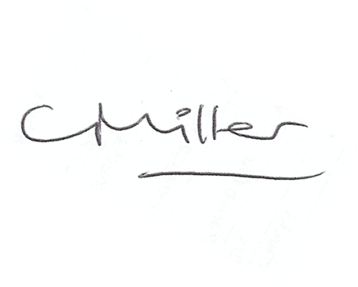
dated this 7th day of May 2021
Claire Miller, Parish Clerk

BAVINGTON PARISH COUNCIL
RISK ASSESSMENT FOR RESUMING FACE-TO-FACE MEETINGS

Risk | Description of Risk | Mitigation Measures
1.Room Set up and Dismantling | Transmission from setting out the chairs to hold the meeting. | Chairs and surfaces, eg door handles to be sanitised after use – members to sanitise their own chairs; Clerk/Chairman to undertake sanitisation on other areas.
2. Entering and leaving meeting | Close proximity to other members and the public entering and leaving the meeting and contact with doors. | Members to enter the meeting and leave in an orderly socially distanced way.  Hands to be sanitised on arrival.  Controlled, socially distanced, one by one, entry by other attendees.
3. Meeting Environment | Transmission through air and touch. | Socially distanced seating arrangement.  Windows and doors to be left open to facilitate the free flow of air though the meeting room.
5. Conduct of Meeting | Transfer through touch and air | Members and public to remain socially distanced at all times.  Wearing of masks except when speaking.  Shouting to be avoided.  The circulation of paper documents to be suspended.
6. Wider Issues | Members do not feel safe attending face to face meetings. | Members to stand when addressing the meeting so their voices will carry better.  Need to keep meeting “moving” so it does not last longer than necessary.
 | Track & trace | Contact details of any members of the public attending to be taken.

Risk Assessment for Face to Face meetings
May 2021
.

