Minutes of meeting of Bavington Parish Council held on Thursday 5th May 2016, commencing 705pm at Great Bavington Church Hall
Those Present Peter Acton (Chairperson), Catherine Hogg, John Spearman, Peter Ramsden, Claire Miller (Clerk)

2016/10 Apologies for Absence
Carol Brodie, Richard Taylor, Nicola Bell

2016/11 Disclosure of interests by members regarding agenda items
There were no Declarations of Interest.

2016/12 Approval of minutes taken at the meeting held 4th February 2016
The minutes of the previous meeting were agreed as a true record.

2016/13 Matters arising from meeting held 4th February 2016
- Northumberland County Council had acknowledged receipt of tree works, stating there was a backlog of work within the parish. As remedial works had not been actioned, Clerk to recontact K Westerby and stress the area remains a concern for the Parish Council.
- A large number of potholes had been reported to County Council by J Spearman via telephone several weeks ago – Clerk to report these by writing and to include additional areas, stressing several places constitute severe danger to vehicles/cyclists.

2016/14 Correspondence
- Northumberland County Council – tree clearance
- Northumberland County Council – Wildlife & Countryside Act 1981 – Definitive Map Modification Order (No 1) 2016 – changes noted
- Request to display advertisement for St Francis Xavier R.C. Chapel, Cheesburn Grange
- Northumberland County Council – Love Northumberland Awards 2016
- Northumberland County Council – Notice of Joint County Council/Parish Council meetings
- CAN – newsletters – March/April 2016

2016/15 Finance
2016/15/01 The following invoices were authorised
- Zurich – annual insurance premium - £236.98 – discussion followed regarding public liability/risks
- Hire of Great Bavington URC – notice of formal hiring arrangements at £25/meeting (£100 per annum) – however this may change therefore payment not authorised.
2016/15/02 Audit of Accounts 2015-2016
- Financial information circulated to all and Section 1 Annual Governance Statement and Section 2 Accounting Statement 2015/16 authorised and signed.
2016/15/03 Any other financial matters
- Lloyds Bank mandate signed to amend official address of Parish Council for statements to be forwarded to Clerk.

2016/16 Planning
2016/16/01 Planning Applications
No planning applications received.

2016/16/02 Neighbourhood Plan
To be taken off agenda.

2016/16/03 Any other Planning Matters
There were no other planning matters.

2016/17 Ponteland school consultation
Consultation ongoing to close Ponteland middle school, however it was now thought the school had been offered academy status, which would overrule this proposal. Parish Council supported three tier system with concerns expressed changes would lead to inadequate facilities , Peter Ramsden to respond to consultation document on behalf of Parish Council.

2016/18 Risk Assessment
Proposed risk assessment circulated to all and it was agreed to adopt the document.

2016/19 Any other Business
- Nicola Bell had activated Bavington e-news and would be thanked for her endeavours with this.
- Community ray windfarm fund to have anticipated income of £250K annually, for 25 years, with Peter Ramsden to sit on Steering Group – with one representative from the six Parish Council’s and also a lay person from each parish to sit on the committee. CAN had advertised for expressions of interest to join the Steering Group, with one application received from Bavington, 3 from Birtley, 2 from Corsenside, 2 from Elsdon and 5 from Kirkwhelpington, and further persons outside of these parishes had also put themselves forward to sit on the Group. Administration of group to be put out to tender. Members of the community were surveyed with response rate of 13%. Areas of greatest interest were improvements to local transport/community transport /improved broadband connectivity / maintenance of village halls and community buildings/young person’s employment/home energy efficiency and support for local leisure facilities. Individual applications would not be excluded.
- Know Northumberland report received, with data concerning housing, with affordable home increase; projection of increase in households; energy, climate change and waste data with energy consumption dropping; residual household waste falling; recycling increasing year on year.

2016/20 Date of Next Meeting
The next meeting of Bavington Parish Council will be held on Thursday 4th August 2016 commencing 7pm at Great Bavington Church Hall.
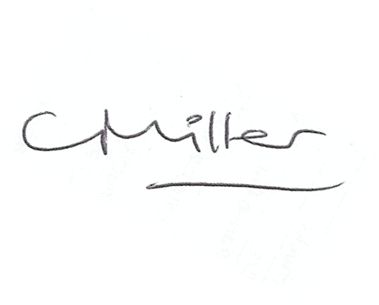
Claire Miller
Parish Clerk

