Minutes of electronic meeting of Bavington Parish Council held on Thursday 5th November 2020 commencing at 7pm
Those Present: P Acton (Chairman), C Hogg, L Robson, P Ramsden, C Miller (Clerk)

2020/30 Apologies for Absence
J Spearman and R Taylor, with apologies accepted.

2020/31 Disclosure of interests by members regarding agenda items
There were no disclosure of members interests

2020/32 Approval of minutes taken at the meeting held 6th August 2020
It was resolved that the minutes of the previous meeting held on 6th August 2020 be accepted as a true record.

2020/33 Matters arising from meeting held 6th August 2020
- Mud on road at Thockrington corner: There were no problems with mud on the road at the present time.

2020/34 Ray Wind Farm Fund
Most of the monies are being spent on supporting Covid hardship issues, such as equipping businesses with PPE and screens and the current allocation will be used exclusively for Covid applications. Vattenfall have agreed to give the Ray Wind Farm CIC the whole of the financial allocation next year as opposed to some funds going to the Community Foundation.

2020/34/01 To receive update on six parishes youth consultation
North Tyne Youth had arranged consultation events during October half-term at West Woodburn, Otterburn and Ridsdale, with the Ridsdale event very well attended.

2020/34/02 To receive information regarding B4RN/B4NTR Broadband matters
The first cabinet should be installed at Barrasford in the near future, and the group are keen for local investment to come forward to support this first stage of connection, with just under £50K of local investment required. The group are also keen for persons to sign up to the voucher scheme. L Armstrong had been visiting landowners regarding signing up to the wayleave scheme, with one problem encountered regarding a farm route, however other options could be taken. Bavington parish has no large estates and is predominately owner occupier which makes the wayleave scheme simpler.

2020/35 Correspondence:
40mph speed limit Little Bavington – parishioner had written to County Council thanking them for implementing the 40mph zone to Little Bavington and the blind bend and new village signs had also been installed. It was agreed the measures had made an improvement.

2020/36 Finance
2020/36/01 To approve the following payments:
- Spanglefish – annual web-site fee - £103.00
It was resolved to approve the payment.
2020/35/02 To consider grants to the following
- Great North Air Ambulance – it was resolved £100 would be granted.
- Tynedale Hospice - it was resolved £100 would be granted.
- St Aidan’s Thockrington - annual grounds maintenance of graveyard – income had drastically reduced due to Covid – it was resolved £100 would be granted.
- Sport Tynedale - no grant to be given.
- AgeUK Northumberland – C Hogg had been contacted by Age UK to deliver activity packs for the elderly in the parish and significant funding had been granted to the organisation by the Ray Wind Farm. It was resolved no grant would be given.

2020/35/03 To consider and approve 2020-2021 budget and precept requirements
After consideration, it was resolved to approve the budget for 2020-2021 and approve the precept of £1600 for 2021-2022.

2020/35/04 To note that following the conclusion of the 2020/21 NJC pay award, a 2.75% rise backdated from 1/4/20 will be included in Clerk salary payment February 2021
The above was noted.

2020/36 Planning
2020/36/01 Planning Applications received
- 20/02750/LBC: Ladywell, Replace 15 double glazed sash and case windows, two double glazed doors and replace patio door with bifold door – no objections.

2020/36/02 Approval of Planning Application received
No approval of planning application had been received.

2020/36/03 Northumberland Local Plan – Notification of Phase 2 Examination Hearings
Phase 2 examination hearings being held at the present time, with the plan scheduled to be adopted March 2021

2020/37 LTP 2021-2022
Passing places on road from Plashetts to Carrycoats; and formalising passing places on unclassified road from B6342 to Great Bavington had been included in 2020-21 programme with County Council confirming passing places did not score highly enough to be included in the Local Transport Plan. No items to be requested for 2021-2022.

2020/38 Web-site Accessibility Regulations
Accessibility Statement had been uploaded onto web-site. The site is created in HTML5, the underlying code is valid and uncomplicated and the website should be fully accessible using screen readers. Some older PDF’s were not fully accessible, however all future documents should be accessible.

2020/39 Any other Business
There was no other business.

2019/40 Date of Next Meeting
The next meeting of Bavington Parish Council will be held on Thursday 4th February 2021 commencing 7pm.

The meeting closed at 735pm.

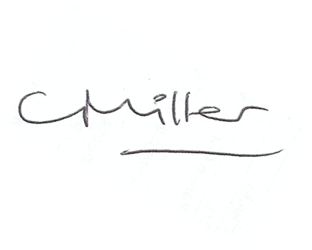
Claire Miller, Parish Clerk

