Minutes of ordinary meeting of Bavington Parish Council held on Thursday 5th August 2021 commencing at 7pm in Great Bavington URC meeting room

Those Present: P Acton (Chairman), P Ramsden, R Taylor J Spearman, C Hogg, C Miller (Clerk)

2021/30 Apologies for Absence
L Robson

2021/31 Disclosure of interests by members regarding agenda items
There were no declaration of interests.

2021/32 Approval of minutes taken at the meeting held 18th May 2021
It was resolved that the minutes of the previous meeting held on 18th May 2021 be accepted as a true record.

2021/33 Matters arising from meeting held 18th May 2021
There were no matters arising from the meeting held 18th May 2021

2021/34 Ray Wind Farm Fund
A new tranche of funds were imminent which would not be solely directed to Covid hardship.

2021/34/01 To receive information regarding B4RN/B4NTR Broadband matters
Routes were being walked, and it is likely Bavington will follow the Barrasford line. The Parish Council were fully supportive of the proposals and look forward to progress.

2021/35 Finance
2021/35/01 To approve payments
There were no payments to approve.

2021/36 Planning
2021/36/01 Planning Applications received
- 21/02474/FUL: Land Through North of Caverton – resubmission, proposed farm access track - it was resolved the Parish Council would submit the previous concerns, that they do not feel able to support the application with persistent problems regarding mud on the road, particularly accumulating on the dangerous corner at Thockrington, which could cause a serious accident.

2021/36/02 Approval of Planning Application received
There had been no approvals received.

2021/36/03 Northumberland Local Plan Examination – Consultation on Main Modifications
The plan in its current form would not pass the independent examination, therefore a further consultation was underway, however there did not appear to be any addidtions to the parish contained within the document.

2021/37 To approve Local Transport Plan priorities for 2022-23
It was agreed to request resurfacing of the unnamed road from A696 to Great Bavington, which is in urgent need of repair.

2021/38 Any other Urgent Business/Items for Next Meeting
There were no items of urgent business or items for the next meeting.

2021/39 Date of Next Meeting
The next meeting of Bavington Parish Council will be held on Thursday 4th November 2021 commencing 7pm in Great Bavington URC meeting room.

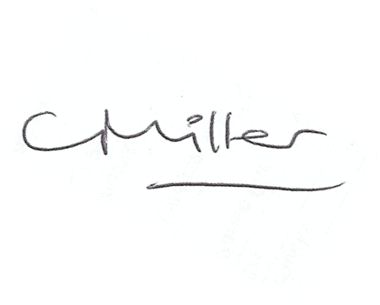
Claire Miller, Parish Clerk
The meeting closed at 730pm.

