Minutes of electronic meeting of Bavington Parish Council held on Thursday 4th February 2021 commencing at 7pm

Those Present: P Acton (Chairman), P Ramsden, R Taylor, L Robson, C Hogg, C Miller (Clerk)

2021/01 Apologies for Absence
J Spearman

2021/02 Disclosure of interests by members regarding agenda items
There were no declaration of interests.

2021/03 Approval of minutes taken at the meeting held 5th November 2020 and extraordinary meeting held 7th December 2020
It was resolved to accept the minutes of the previous meeting held on 5th November 2020 and minutes of extraordinary meeting held 7th December 2020 as a true record.

2021/04 Matters arising from meeting held 5th November 2020 and extraordinary meeting held 7th December 2020
There were no matters arising from the meeting held 5th November 2020 and extraordinary meeting held 7th December 2020.

2021/05 Ray Wind Farm Fund
Covid related hardship applications still being supported, with £40K in the current allocation.

2021/05/01 To receive update on six parishes youth consultation
Forthcoming digital events organised for February half-term: Tuesday 16th – 6 to 7pm, pilates; Thursday 18th – 6 to 630pm, Street Dance; 7 – 830pm Stargazers Dark Skies.

2021/05/02 To receive information regarding B4RN/B4NTR Broadband matters
Works centered around cabinet at Barrasford which should be installed within the next fortnight, and group keen for as many people as possible to sign up to the voucher scheme which runs out at the end of March 2021. The group to hold a public zoom meeting on 17/2/21.

2021/06 Correspondence
There was no correspondence.

2021/07 Finance
2021/07/01 To approve the following payments:
- C Miller – annual salary & expenses - £541.76
- HMRC – PAYE on above - £130.20

It was resolved to approve the payments.

2020/07/02 To receive acknowledgement of grant from Tynedale Hospice at Home; Great Air Ambulance and St Aidan’s Thockrington
Acknowledgements noted.

2021/08 Planning
2021/08/01 Planning Applications received
- 20/03660/CCMEIA: Divet Hill Quarry – Lateral extension to north of existing quarry boundary for the phased extraction of approximately 2.7 million tonnes of whinstone and restoration of site to agricultural grassland and nature conservation uses – objection submitted as minuted in extraordinary meeting 7/12/20.
- 20/03661/VARCCM: Divet Hill Quarry – Variation of conditions 1 to 17/04637/VARCCM to extend the duration of consented operations, amend the approved documentation associated with the operation and amend the noise limits applicable to the operation – objection submitted as minuted in extraordinary meeting 7/12/20.

Quarry alarm had gone off on Christmas Eve, rung all night and most of Christmas Day. C Hogg had subsequently contacted Donald Wilkins and a response had been received with quarry manager asked to action problem – there was no emergency contact number at the quarry entrance and manager had confirmed details were to be displayed.

2021/08/02 Approval of Planning Application received
- 20/01806/FUL: Newonstead Kirkharle – Replacement garden room

2021/09 Review of Internal Auditor and Internal Controls
It was resolved to retain the services of the present internal auditor, D Metcalfe.
It was resolved the current internal controls were sufficient for the present needs of the Parish Council.

2021/10 Review of Risk Assessment
It was resolved the document was sufficient for the present needs of the Parish Council.

2021/11 Review of Asset Register
It was resolved the Asset Register was an accurate record of the Parish Council assets.

2021/12 Review of insurance policy
It was resolved the current insurance policy was sufficient for the present needs of the Parish Council. Public liability currently £10million and other insurance values included in Risk Assessment.

2021/13 Review of Standing Orders
It was resolved the document was sufficient for the present needs of the Parish Council.

2021/14 Review of Bank Signatories
Current bank signatories, J Spearman, C Miller and C Hogg and considered sufficient at the present time.

2021/14 Any other Business
The County and Parish Council elections were still scheduled to go ahead May 2021.

2021/15 Date of Next Meeting
The next meeting of Bavington Parish Council will be held on Tuesday 18th May 2021 commencing 7pm.

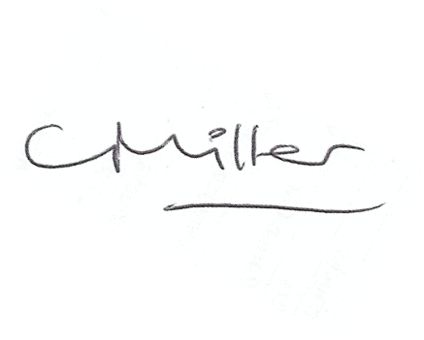
The meeting closed at 730pm.
Claire Miller, Parish Clerk

