Minutes of the Annual meeting of Bavington Parish Council held on Tuesday 18th May 2021 commencing at 7pm in
Great Bavington URC Church meeting room
Those Present: P Acton (Chairman), P Ramsden, R Taylor, C Hogg, J Spearman, C Miller (Clerk)

2021/17 Apologies for Absence
L Robson

2021/18 Election of Chairman
Cllr Acton proposed and seconded as Chairman, and duly elected.

2021/19 Election of Vice Chairman
Cllr Taylor proposed and seconded as Vice Chairman and duly elected.

2021/20 Disclosure of interests by members regarding agenda items
There were no disclosure of members interests.

2021/21 Approval of minutes taken at the meeting held 4th February 2021
It was resolved that the minutes of the previous meeting held 4th February 2021 be accepted as a true record.

2021/22 Matters arising from meeting held 4th February 2021
There were no matters arising from the meeting held 4th February 2021.

2021/23 Ray Wind Farm Fund
Funds this year had largely been spent on grants related to circumstances due to the Covid-19 pandemic. A further installment of approximate £170K funds to be received end June 2021 by Community Interest Company, with £100K to be received by the Community Foundation. A smaller fund was available for requests up to £500.

2021/23/01 To receive information regarding B4RN/B4NTR Broadband matters
The local representative was to host a zoom meeting 25/5/21 in order for the routes for the cable installation to be organised.

2021/24 Correspondence
https://northumberland.moderngov.co.uk/documents/s2141/Public%20Library%20Service%20Consultation.pdf
https://northumberland.moderngov.co.uk/documents/s2143/App%202.pdf

2021/25 Finance
2021/25/01 To approve the following payments:
- NALC – Annual subscription fee - £52.50
- Came & Company – Annual insurance premium - £218.00

It was resolved to approve the payments.

2021/26 Audit of Accounts year ending 31/3/21
2021/26/01 To consider and agree any actions arising from the report of the internal auditor
There were no matters arising from the report of the internal auditor.

2021/26/02 To approve the Governance Statement
It was resolved to approve the Governance Statement.

2021/26/03 To approve the draft annual accounts for 2020/2021
It was resolved to approve the draft annual accounts for 2020/2021.

2021/26/04 To approve the Accounting Statement and explanation of variances
It was resolved to approve the Accounting Statement and explanation of variances.

2021/26/05 To approve the Exemption Certificate
It was resolved to approve the Exemption Certificate.

2021/26/06 To confirm public right of inspection dates
It was resolved to approve the public right of inspection dates from 14 June to 23 July 2021.

2021/27 Planning
2021/27/01 Planning Applications received
No planning applications had been received.

2021/27/02 Approval of Planning Application received
No approval of planning application had been received.

2021/27/03 Planning Application withdrawal
- 20/02266/FUL: Land Through North of Caverton Plantation Capheaton – Proposed farm access

2021/28 Any other Business
It was pleasing to note potholes within the parish had been actioned.
A statutory objection had been submitted regarding the Divethill quarry proposals.

2021/29 Date of Next Meeting
The next meeting of Bavington Parish Council will be held on Thursday 5th August 2021 commencing 7pm at Great Bavington URC Church meeting room

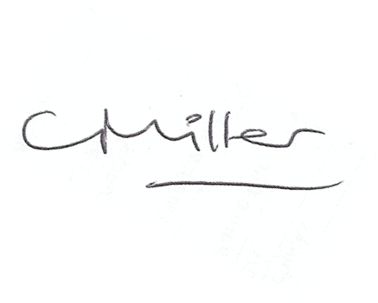
The meeting closed at 740pm.
Claire Miller, Parish Clerk

BAVINGTON PARISH COUNCIL
RISK ASSESSMENT FOR RESUMING FACE-TO-FACE MEETINGS

Risk | Description of Risk | Mitigation Measures
1.Room Set up and Dismantling | Transmission from setting out the chairs to hold the meeting. | Chairs and surfaces, eg door handles to be sanitised after use – members to sanitise their own chairs; Clerk/Chairman to undertake sanitisation on other areas.
2. Entering and leaving meeting | Close proximity to other members and the public entering and leaving the meeting and contact with doors. | Members to enter the meeting and leave in an orderly socially distanced way.  Hands to be sanitised on arrival.  Controlled, socially distanced, one by one, entry by other attendees.
3. Meeting Environment | Transmission through air and touch. | Socially distanced seating arrangement.  Windows and doors to be left open to facilitate the free flow of air though the meeting room.
5. Conduct of Meeting | Transfer through touch and air | Members and public to remain socially distanced at all times.  Wearing of masks except when speaking.  Shouting to be avoided.  The circulation of paper documents to be suspended.
6. Wider Issues | Members do not feel safe attending face to face meetings. | Members to stand when addressing the meeting so their voices will carry better.  Need to keep meeting “moving” so it does not last longer than necessary.
 | Track & trace | Contact details of any members of the public attending to be taken.

Risk Assessment for Face to Face meetings
May 2021
.

