KIRKWHELPINGTON PARISH COUNCIL
AGENDA PAPER
You are hereby summoned to attend a meeting of Kirkwhelpington Parish Council to be held at the Memorial Hall, Kirkwhelpington on the 5th day of July 2016 at 7.30pm, for the purpose of transacting the business contained within this agenda
2016/39 Apologies for Absence
2016/40 Declarations of Interest
2016/41 Minutes of meeting held 3rd May 2016
2016/42 Matters arising from meeting held 3rd May 2016
2016/43 Youth Club
2016/44 Correspondence
- Northumberland County Council – 2016 Surface Dressing
- Northumberland County Council – Core Strategy, final consultation

2016/45 Finance
2016/45/01 Bank Balance: £13091.46 as at 23/6/16
2016/45/02 Invoices for payment
- Kirkwhelpington Memorial Hall – W/C maintenance - £255.50
- Proludic - - swing installation - £4798.80
- NALC – annual subscription - £87.05
- C Miller – 6 monthly salary & expenses - £741.19
- HMRC – Paye on above - £160.00
- Robson & Cowan – Parts and fuel - £47.

2016/45/03 Grasscutting machinery: Big Lottery Fund – notice of unsuccessful funding bid

2016/46 Planning Matters
2016/46/01 Planning Applications:
2016/46/02 Approval of Planning Application:
2016/46/03 Northumberland County Council: Core Strategy/Renewable Energy Consultation

2016/47 Play Ground
2016/48 Urgent Business
2016/49 Information Items
2016/50 Date of next Meeting

Dated this day of 23rd June 2016.
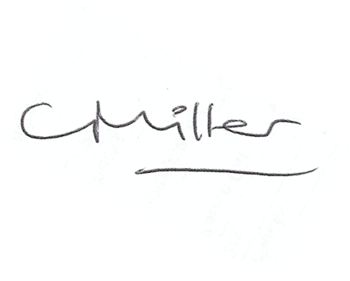
Claire Miller
Parish Clerk

www.parish-council.com/kirkwhelpington/index.asp?pageid=623489

