KIRKWHELPINGTON PARISH COUNCIL
AGENDA PAPER
You are hereby summoned to attend a meeting of Kirkwhelpington Parish Council to be held at the Memorial Hall, Kirkwhelpington on the 1st day of November 2016 at 7.30pm, for the purpose of transacting the business contained within this agenda
PART ONE
2016/65 Apologies for Absence
2016/66 Declarations of Interest
2016/67 Sulphur Well: Notice of cancellation of hearing scheduled for 17/11/16
2016/68 Minutes of meeting held 13th September 2016
2016/69 Matters arising from meeting held 13th September 2016
2016/70 Bonfire Night
2016/71 Youth Club
2016/72 Correspondence
2016/73 Finance
2016/73/01 Bank Balance: £8262.79 as at 31/10/16
2016/73/02 Invoices for payment
- Kirkwhelpington Memorial Hall – W/C maintenance - £255.50
- Mr B Nevin & Mr Rogerson – grasscutting
2015/73/03 Precept/Budget 2017-2018
2016/74 Planning Matters
2016/74/01 Planning Applications:
16/00383/PREAPP, J Anderson, North Side, Kirkharle – concreting over present hardcore standing between existing agricultural building
2016/74/02 Approval of Planning Application:
2016/75 Play Ground
2016/76 Ray Fell Wind Farm: Request from Bavington Parish Council to make comment to Vattenfall expressing disappointment and shock at the adverse effect of the development on surrounding landscape
2016/77 Urgent Business
2016/78 Information Items
- Tynedale Hospice at Home - newsletter
2016/79 Date of next Meeting

PART TWO: PRIVATE SESSION
2016/80 To agree grasscutting pay rates 2017
Dated this 21st day of October 2016.
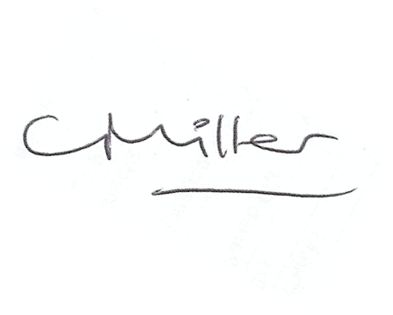
Claire Miller
Parish Clerk

www.parish-council.com/kirkwhelpington

