KIRKWHELPINGTON PARISH COUNCIL
AGENDA PAPER
You are hereby summoned to attend a meeting of Kirkwhelpington Parish Council to be held at the Memorial Hall, Kirkwhelpington on the 13th day of September 2016 at 7.30pm, for the purpose of transacting the business contained within this agenda
2016/51 Apologies for Absence
2016/52 Declarations of Interest
2016/53 Sulphur Well
2016/54 Minutes of meeting held 5th July 2016
2016/55 Matters arising from meeting held 5th July 2016
2016/56 Bonfire Night
2016/57 Youth Club
2016/58 Correspondence
- Northumberland Association of Local Councils – future County Council budget cuts
2016/59 Finance
2016/59/01 Bank Balance: £9796.02 as at 31/8/16
2016/59/02 Invoices for payment
- Kirkwhelpington Memorial Hall – W/C maintenance - £255.50
- Robson & Cowan - Grasscutting machinery - £419.00/Fuel - £48.40
2015/59/03 Request for Donation
- Community Action Northumberland
2016/59/04 Grasscutting machinery: Northumberland County Council – notice of grant award

2016/60 Planning Matters
2016/60/01 Planning Applications:
2016/60/02 Approval of Planning Application:
- 15/02054/FUL: Land East of Eastlands, 17 residential dwellings – Northumberland Estates
2016/60/03 The Planning Inspectorate – Definitive Map Modification Order (No 13) 2014 Footpath No 44 (Parish of Kirkwhelpington)

2016/61 Play Ground: Play Safety Inspection Report
2016/62 Urgent Business
2016/63 Information Items
2016/64 Date of next Meeting

Dated this 2nd day of September 2016.
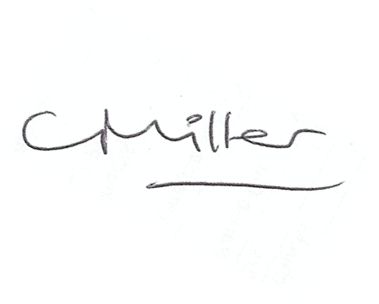
Claire Miller
Parish Clerk

www.parish-council.com/kirkwhelpington

