KIRKWHELPINGTON PARISH COUNCIL
AGENDA PAPER
You are hereby summoned to attend a meeting of Kirkwhelpington Parish Council to be held at the Memorial Hall, Kirkwhelpington on the 1st day of March 2016 at 7.30pm, for the purpose of transacting the business contained within this agenda
2016/14 Apologies for Absence

2016/15 Declarations of Interest

2016/16 Minutes of meeting held 12th January 2016
2016/17 Matters arising from meeting held 12th January 2016

2016/18 Youth Club

2016/19 Correspondence
- NCC – Local Development Framework
- NCC – Street Lighting
2016/20 Finance
2016/20/01 Bank Balance: £2961.37
2016/20/02 Invoices for payment
- Kirkwhelpington Memorial Hall - £255.50
2016/20/03 Future of Pantomime
2016/20/04 Other financial matters

2016/21 Planning Matters
2016/21/01 Planning Applications:
2016/21/02 Approval of Planning Application:
2016/21/03 Any Other Planning Matters

2016/22 Play Ground

2016/23 Annual Review of Risk Assessment

2016/24 Urgent Business

2016/25 Information Items

2016/26 Date of next Meeting

Dated this 19th day of February 2016.
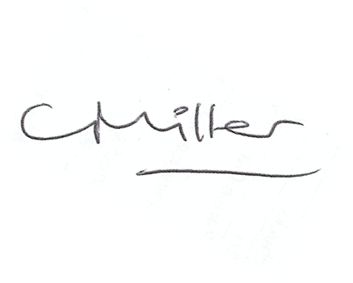
Claire Miller
Parish Clerk

