KIRKWHELPINGTON PARISH COUNCIL
AGENDA PAPER
You are hereby summoned to attend a meeting of Kirkwhelpington Parish Council to be held at the Memorial Hall, Kirkwhelpington on the 3rd day of May 2016 at 7.30pm, for the purpose of transacting the business contained within this agenda
2016/27 Apologies for Absence
2016/28 Declarations of Interest

2016/29 Minutes of meeting held 1st March 2016

2016/30 Matters arising from meeting held 1st March 2016

2016/31 Youth Club

2016/32 Correspondence
- Forestry Commission – Sweethope Lough Roading screening consultation
- ISOS Housing – service charge
- Northumberland County Council – Consultation on proposal for Ponteland Partnership
- Request to display advertisement for St Francis Xavier R.C. Chapel, Cheesburn Grange, Stamfordham
- Northumberland County Council – flooding reported on roads - acknowledgement
2016/33 Finance
2016/33/01 Bank Balance: £10374.17 as at 18/4/16
2016/33/02 Invoices for payment
- Kirkwhelpington Memorial Hall – W/C maintenance - £255.50
- Robson & Cowan – Fuel - £43.68
- Northumberland & Newcastle Society – annual membership - £25.00
2016/33/03 Audit of Accounts year ending 31/3/16
2016/33/04 Any other financial matters

2016/34 Planning Matters
2016/34/01 Planning Applications:
2016/34/02 Approval of Planning Application:
2016/34/03 Any Other Planning Matters

2016/35 Play Ground
2016/36 Urgent Business
2016/37 Information Items
2016/38 Date of next Meeting
Dated this 18th day of April 2016.
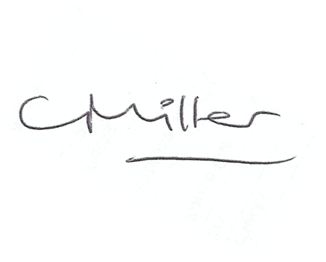
Claire Miller
Parish Clerk

