KIRKWHELPINGTON PARISH COUNCIL
AGENDA PAPER
You are hereby summoned to attend a meeting of Kirkwhelpington Parish Council to be held at the Memorial Hall, Kirkwhelpington on Tuesday 3rd of January 2017 at 7.30pm, for the purpose of transacting the business contained within this agenda
PART ONE
2017/01 Apologies for Absence
2017/02 Declarations of Interest
2017/03 Public questions
2017/04 Sulphur Well
2017/05 Matters arising from meeting held 1st November 2016
2017/06 Youth Club
2017/07 Correspondence
- Northumberland Theatre Co – productions
- The Planning Inspectorate – Sulphur Well
2017/08 Finance
2017/08/01 Bank Balance: £5881.97 as at 31/12/16
2017/08/02 Invoices for payment
- Kirkwhelpington Memorial Hall – W/C maintenance - £255.50
- Playsafety Ltd – playground inspection - £105.00
- C Miller – six monthly salary and expenses - £741.50
2017/08/03 Request for Donation
- Northumberland CVA
2017/08/04 Clerks Salary (to be discussed in private session)
2017/09 Planning Matters
2017/09/01 Planning Applications
2017/09/02 Approval of Planning Application
2017/10 Play Ground
2017/11 Ray Fell Wind Farm
2017/12 Urgent Business
2017/13 Information Items
- City and County newsletter
- NCC – winter services
- NCC – Archaeology in Northumberland
2017/14 Date of next Meeting
Dated this 21st day of December 2016.
PART TWO – PRIVATE SESSION
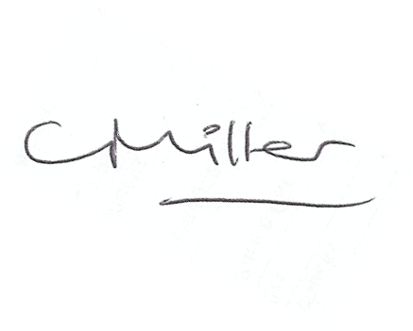
Claire Miller
Parish Clerk

www.parish-council.com/kirkwhelpington

