KIRKWHELPINGTON PARISH COUNCIL
AGENDA PAPER
You are hereby summoned to attend a meeting of Kirkwhelpington Parish Council to be held at the Memorial Hall, Kirkwhelpington on Tuesday 4th of July 2017 at 7.30pm, for the purpose of transacting the business contained within this agenda
2017/48 Apologies for Absence
2017/49 Declarations of Interest
2017/50 Public questions
2017/51 Minutes of previous meeting
2017/52 Matters arising from previous meeting
- Verges
- Meadowlands Wall
- Overhanging Trees
- Sulphur Well footpath
- Dumping of wood
- Village seats
2017/53 Youth Club
2017/54 Correspondence
- Mrs G Bristow, land east of Eastlands, proposed development
- Northumberland County Council – The Green Dog Walkers Responsible Dog Ownership Campaign
- Northumberland County Council – Wannylaw road closure

2017/55 Finance
2017/55/01 Bank Balance: £6218.93 as at 30/06/17
2017/55/02 Invoices for payment
- Kirkwhelpington Memorial Hall – W/C maintenance - £255.50
- C Miller – May, June salary and expenses - £256.08
- HMRC - PAYE on above - £54.40
2017/55/03 Acknowledgement of Donation
- Kirkwhelpington and Kirkharle PCC

2017/56 Planning Matters
2017/56/01 Planning Applications received
2017/56/02 Approval of Planning Application

2017/57 Play Ground
2017/58 Ray Fell Wind Farm/Community Benefit Fund
2017/59 Urgent Business
2017/60 Information Items
- City and County - newsletter
2017/61 Date of next Meeting
Dated this 21st day of June 2017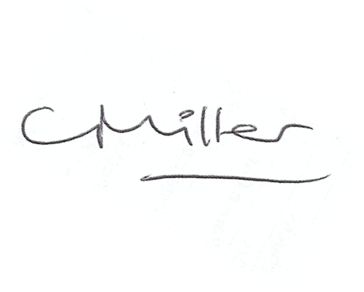
Claire Miller
Parish Clerk

www.parish-council.com/kirkwhelpington

