KIRKWHELPINGTON PARISH COUNCIL
AGENDA PAPER
You are hereby summoned to attend a meeting of Kirkwhelpington Parish Council to be held at the Memorial Hall, Kirkwhelpington on Tuesday 7th of March 2017 at 7.30pm, for the purpose of transacting the business contained within this agenda
PART ONE
2017/15 Apologies for Absence
2017/16 Declarations of Interest
2017/17 Public questions
2017/18 Sulphur Well
2017/19 Minutes of previous meeting
2017/20 Matters arising from previous meeting
2017/21 Youth Club
2017/22 Correspondence
- CAN – Getabout Access Scheme
- C Dilger – overhanging trees/Vodafone mobile coverage

2017/23 Finance
2017/23/01 Bank Balance: £4277.97 as at 28/02/17
2017/23/02 Invoices for payment
- Kirkwhelpington Memorial Hall – W/C maintenance - £255.50
- C Miller – January, February salary and expenses - £248.25
- HMRC - PAYE on above - £53.20
- Northumberland Estates – rent in arrears 2/2/17 to 1/2/17 - £5.25
2017/24 Planning Matters
2017/24/01 Planning Applications received:
- 17/00026/PRUTPO: Clairley Kirkwhelpington – tree pruning
2017/24/02 Approval of Planning Application
2017/25 Play Ground
2017/26 Annual review of Risk Assessment
2017/27 Ray Fell Wind Farm
2017/28 Urgent Business
2017/29 Information Items
- City and County newsletter
2017/30 May 2017 Elections
2017/31 Date of next Meeting
Dated this 23rd day of February 2017
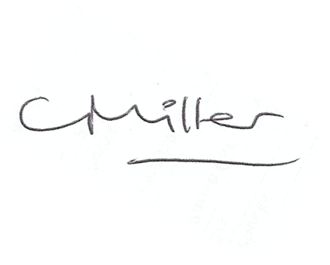
Claire Miller
Parish Clerk

www.parish-council.com/kirkwhelpington

