KIRKWHELPINGTON PARISH COUNCIL
AGENDA PAPER
You are hereby summoned to attend a meeting of Kirkwhelpington Parish Council to be held at the Memorial Hall, Kirkwhelpington on Tuesday 9th of May 2017 at 7.30pm, for the purpose of transacting the business contained within this agenda
2017/32 Apologies for Absence
2017/33 Declarations of Interest
2017/34 Public questions
2017/35 Minutes of previous meeting
2017/36 Matters arising from previous meeting
- Verges: Confirmation County Council would not carry out work as they were not dangerous but aesthetic, however matter to be passed to Neighbourhood Services who may action
- Meadowlands Wall
- Overhanging Trees
2017/37 Sulphur Well: Definitive Map Modification Order (No 13) 2014
2017/38 Youth Club
2017/39 Correspondence
2017/40 Finance
2017/40/01 Bank Balance: £6740.77 as at 30/04/17
2017/40/02 Invoices for payment
- Kirkwhelpington Memorial Hall – W/C maintenance - £255.50
- C Miller – March, April salary and expenses - £336.02
- HMRC - PAYE on above - £54.00
- Robson & Cowan - £24.50 (oil) £50.40 (fuel
- NALC – annual subscription - £88.42
2017/40/03 Request for Donation: PCC of Kirkwhelpington & Kirkharle
2017/40/04 Approval of Annual Governance Statement 2016/17 & Accounting Statements 2016/17
2017/41 Planning Matters
2017/41/01 Planning Applications received
2017/41/02 Approval of Planning Application
2017/42 Play Ground
2017/43 Ray Fell Wind Farm/Community Benefit Fund
2017/44 Urgent Business
2017/45 Information Items
2016/46 Kirkwhelpington Education Trust – trustee nomination
2017/47 Date of next Meeting
Dated this 27th day of April 2017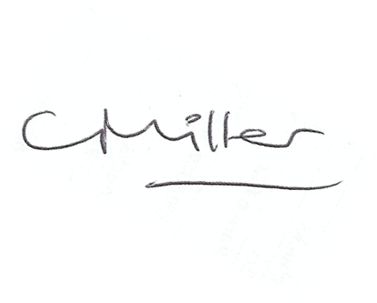
Claire Miller
Parish Clerk

www.parish-council.com/kirkwhelpington

