KIRKWHELPINGTON PARISH COUNCIL
AGENDA PAPER
You are hereby summoned to attend a meeting of Kirkwhelpington Parish Council to be held at the Memorial Hall, Kirkwhelpington on Tuesday 5th of September 2017 at 7.30pm, for the purpose of transacting the business contained within this agenda
2017/62 Apologies for Absence
2017/63 Declarations of Interest
2017/64 Public questions
2017/65 Minutes of previous meeting
2017/66 Matters arising from previous meeting
- Grass Verges
- Meadowlands Wall
- Overhanging Trees
- Sulphur Well
- Dumping of wood
- Seats
- Potholes
- A696 flooding

2017/67 Youth Club
2017/68 Correspondence
- Northumberland County Council – 11/7/17 – notice Sulphur Well path works to be completed within next couple of months
- County Council – LTP 2018 – 19 – to agree/discuss priorities
- County Council – joint meetings with town/parish councils – Monday 9th October
2017/69 Finance
2017/69/01 Bank Balance: £5547.95 as at 31/08/17
2017/69/02 Invoices for payment
- Kirkwhelpington Memorial Hall – W/C maintenance - £255.50
- C Miller – July, August salary and expenses - £256.89
- HMRC - PAYE on above - £54.60
2017/70 Planning Matters
2017/70/01 Planning Applications received
2017/70/02 Approval of Planning Application
2017/70/03 Northumberland Local Plan Core Strategy – withdrawal from Examination
2017/71 Play Ground
2017/72 Ray Fell Wind Farm/Community Interest Company
2017/73 Adoption Parish Council Standing Orders
2017/74 Urgent Business
2017/75 Information Items
2017/76 Date of next Meeting
Dated this 24th day of August 2017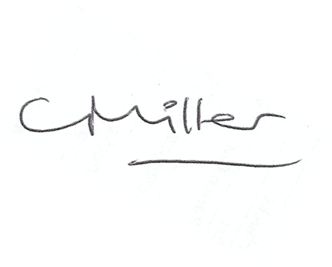
Claire Miller
Parish Clerk

www.parish-council.com/kirkwhelpington

