Agenda for meeting of Kirkwhelpington Parish Council to be held at the Memorial Hall, Kirkwhelpington on Tuesday 3rd July 2018 at 7.30pm
PART ONE

2018/54 Apologies for Absence

2018/55 Declarations of Interest

2018/56 Public questions

2018/57 Minutes of previous meeting held Tuesday 8th May 2018

2018/58 Matters arising from previous meeting held Tuesday 8th May 2018
- Meadowlands Wall:
- Seats
- A696 flooding
- Knowesgate Junction
- White lining, Cornhills
- Grasscutting

2018/59 Correspondence

2018/60 Finance
2018/60/01 Bank Balance: £14650.64 as at 31/5/18
2018/60/02 The following accounts require authorisation:
- Kirkwhelpington Memorial Hall – W/C maintenance - £255.50;
- C Miller – May, June salary and expenses - £257.92 - £269.17
- HMRC - PAYE on above - £55.60
- Robson and Cowan – safety equipment, £47.04; fuel - £27.32
- Request for grant – PCC of Kirkwhelpington with Kirkharle and Kirkheaton
- NALC – annual subscription - £91.34

2018/61 Planning Matters
2018/61/01 Planning Applications received
2018/61/02 Approval of Planning Application
2018/61/03 Northumberland Local Plan Consultation

2018/62 Play Ground – to discuss any issues

2018/63 Update on Ray Fell Wind Farm/Community Interest Company

2018/64 Bonfire Night Celebrations – to discuss organisation of 2018 event

2018/65 Adoption of documents relating to General Data Protection Regulations (GDPR): Information & Data Protection Policy; Publication Scheme and Councillor Details; Subject Access Request Form; Privacy Notice; Email Contact Privacy Notice; Councillor Privacy Notice; Document Retention Policy

2018/66 Local Transport Plan feedback 2018-19

2018/67 Urgent Business

2018/68 Date of next Meeting

PART TWO
That under the Public Bodies (Admission to Meetings) Act 1960, the public and representatives of the press and broadcast media be excluded from the meeting during the consideration of the following items of business as publicity would be prejudicial to the public interest because of the confidential nature of the business to be transacted.
2018/69/PRIVATE Meadowlands Wall insurance implications
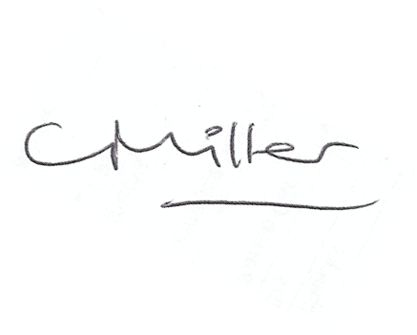
Claire Miller, Parish Clerk, 22nd June 2018

