KIRKWHELPINGTON PARISH COUNCIL
AGENDA PAPER
You are hereby summoned to attend a meeting of Kirkwhelpington Parish Council to be held at the Memorial Hall, Kirkwhelpington on Tuesday 6th March 2018 at 7.30pm, for the purpose of transacting the business contained within this agenda
2018/18 Apologies for Absence
2018/19 Declarations of Interest
2018/20 Public questions
2018/21 Minutes of previous meeting held Tuesday 5th January 2018
2018/22 Matters arising from previous meeting held Tuesday 5th January 2018
- Meadowlands Wall: to discuss notes from informal meeting held 13/2/18; to discuss and agree to accept quotation from contractor and confirm funding bids (to be discussed in private session)
- Seats
- A696 flooding
- Knowesgate Junction
- White lining, Cornhills

2018/23 Youth Club
2018/24 Correspondence
- CPRE – newsletter
- County Council – to discuss and comment on post 16 transport consultation

2018/25 Finance
2018/25/01 Bank Balance: £6682.61 as at 28/02/17
2018/25/02 Invoices for payment
- Kirkwhelpington Memorial Hall – W/C maintenance - £255.50;
- Northumberland Estates – rent for village green - £10.00
- C Miller – January, February salary and expenses - £275.36
- HMRC - PAYE on above - £54.50
- Northumberland & Newcastle Society – annual subscription - £30.00

2018/26 Planning Matters
2018/26/01 Planning Applications received
2018/26/02 Approval of Planning Application
2018/27 Play Ground – to discuss any issues
2018/28 Update on Ray Fell Wind Farm/Community Interest Company
2018/29 Bonfire Night Celebrations – to discuss organisation of 2018 event
2018/30 To discuss termination of parish bus service
2018/31 Annual Review of Risk Assessment
2018/32 Urgent Business
2018/33 Date of next Meeting
PART II
It is expected that matters included in this part of the Agenda will be dealt with in private. Any Reports referred to are enclosed for members and officers only and marked "Not for Publication".
EXCLUSION OF PRESS AND PUBLIC: The Committee is invited to consider passing the following resolution: That under Section 100A (4) of the Local Government Act 1972, the press and public be excluded from the meeting during consideration of the following items on the Agenda as they involve the likely disclosure of exempt information as defined in paragraphs 1, 3 and 5 of Part I of Schedule 12A of the 1972 Act.
1, Information relating to any individual.
3, Information relating to the financial or business affairs of any particular person (including the authority holding the information)
5, Information in respect of which a claim to legal professional privilege could be maintained in legal proceedings.

2018/36/PRIVATE To discuss quotations received for drainage works at play area and confirmation to submit funding applications

2018/37/PRIVATE To discuss applications for grasscutting vacancy

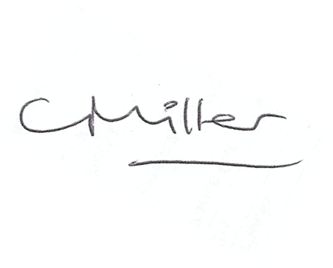
Claire Miller, Parish Clerk, 22nd February 2018

