Agenda for Annual meeting of Kirkwhelpington Parish Council to be held at the Memorial Hall, Kirkwhelpington on Tuesday 8th May 2018 at 7.30pm
PART ONE

2018/38 Apologies for Absence
2018/39 Declarations of Interest
2018/40 Public questions
2018/41 Minutes of previous meeting held Tuesday 6th March 2018
2018/42 Matters arising from previous meeting held Tuesday 6th March 2018
- Meadowlands Wall:
- Seats
- A696 flooding
- Knowesgate Junction
- White lining, Cornhills
- Grasscutting

2018/43 Correspondence
- Northumberland County Council - verge maintenance; Love Northumberland Awards 2018
- Northumberland County Council, road hierarchy consultation

2018/44 Finance
2018/44/01 Bank Balance: £6057.36 as at 31/3/18
2018/44/02 The following invoices were authorised for payment
- Kirkwhelpington Memorial Hall – W/C maintenance - £255.50;
- C Miller – March, April salary and expenses - £257.92
- HMRC - PAYE on above - £54.80
- Robson and Cowan, grasscutting equipment repairs- £274.28 less £10.07 credit = £264.21; fuel - £51.00
- Came and Company – annual insurance premium - £573.28

2018/45 Audit of Accounts year ending 31/3/18
2018/45/01 To consider and agree any actions arising from the report of the internal auditor
2018/45/02 To approve the draft annual accounts for 2017/2018
2018/45/03 To approve the Accounting Statement and explanation of variances
2018/45/04 To confirm and approve the Certificate of Exemption
2018/46 Planning Matters
2018/46/01 Planning Applications received
2018/46/02 Approval of Planning Application
2018/47 Play Ground – to discuss any issues
2018/48 Update on Ray Fell Wind Farm/Community Interest Company
2018/49 Bonfire Night Celebrations – to discuss organisation of 2018 event
2018/50 To receive/discuss information relating to General Data Protection Regulations (GDPR) and agree action plan
2018/51 Urgent Business
2018/52 Date of next Meeting

PART TWO
That under the Public Bodies (Admission to Meetings) Act 1960, the public and representatives of the press and broadcast media be excluded from the meeting during the consideration of the following items of business as publicity would be prejudicial to the public interest because of the confidential nature of the business to be transacted.
2018/53/PRIVATE Meadowlands Wall insurance implications
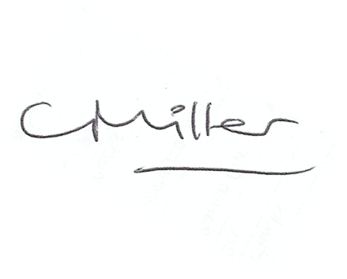
Claire Miller, Parish Clerk, 26th April 2018

