KIRKWHELPINGTON PARISH COUNCIL
AGENDA
Agenda for meeting of Kirkwhelpington Parish Council to be held at the Memorial Hall, Kirkwhelpington on Tuesday 6th November 2018 at 7.30pm
PART ONE
2018/86 Apologies for Absence

2018/87 Declarations of Interest

2018/88 Public questions

2018/89 Minutes of previous meeting held Tuesday 4th September 2018

2018/90 Matters arising from previous meeting held Tuesday 4th September 2018
- Meadowlands Wall
- A696 Flooding
- Trees
- St Oswald’s Way signpost

2018/91 Correspondence
- Notice of vacancy for Parish Council representative on Northumberland Association of Local Council Committee
- CPRE - newsletter

2018/92 Finance
2018/92/01 Bank Balance: £34890.06 as at 30/9/18
2018/92/02 The following accounts require authorisation:
- Kirkwhelpington Memorial Hall – W/C maintenance - £255.50;
- C Miller – September, October salary £221.97 and expenses – £27.36
- HMRC - PAYE on above - £55.60
- Robson & Cowan - £28.00
- Grasscutting
2018/92/03 Request for grant: Core Music; Community Action Northumberland
2018/92/04 To approve submission for funding for football posts
2018/92/05 To approve precept 2019-2020

2018/93 Planning Matters
2018/93/01 Planning Applications received
2018/93/02 Approval of Planning Application

2018/94 Play Ground – monthly inspection

2018/95 Update on Ray Fell Wind Farm/Community Interest Company

2018/96 Urgent Business

2018/97 Date of next Meeting

PART TWO
That under the Public Bodies (Admission to Meetings) Act 1960, the public and representatives of the press and broadcast media be excluded from the meeting during the consideration of the following items of business as publicity would be prejudicial to the public interest because of the confidential nature of the business to be transacted.
2018/98/PRIVATE Meadowlands Wall insurance implications

2018/99/PRIVATE To agree grasscutting pay rates 2019

Dated this 26th day of October 2018.

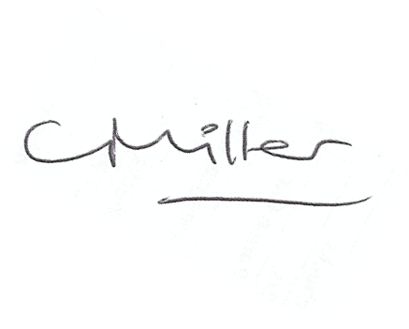
Claire Miller, Parish Clerk

