KIRKWHELPINGTON PARISH COUNCIL
AGENDA
Agenda for meeting of Kirkwhelpington Parish Council to be held at the Memorial Hall, Kirkwhelpington on Tuesday 4th September 2018 at 7.30pm
PART ONE

2018/70 Apologies for Absence

2018/71 Declarations of Interest

2018/72 Public questions

2018/73 Minutes of previous meeting held Tuesday 3rd July 2018

2018/74 Matters arising from previous meeting held Tuesday 3rd July 2018
- Meadowlands Wall
- A696 Flooding
- Knowesgate Junction
- Grasscutting
- Trees

2018/75 Correspondence
- CPRE – newsletter
- County Council – disposing of hazardous waste
- County Council – notice of Annual Town and Parish Conference 11/10/18

2018/76 Finance
2018/76/01 Bank Balance: £23544.67 as at 31/7/18
2018/76/02 The following accounts require authorisation:
- Kirkwhelpington Memorial Hall – W/C maintenance - £255.50;
- C Miller – July, August salary and expenses - £261.85
- HMRC - PAYE on above - £55.40

2018/76/03 To approve quotation for dog fouling signage
2018/76/04 To approve quotation for football posts
2018/76/05 To receive letter of thanks for grant awarded to PCC

2018/77 Planning Matters
2018/77/01 Planning Applications received
2018/77/02 Approval of Planning Application

2018/78 Play Ground – to discuss any issues

2018/79 Update on Ray Fell Wind Farm/Community Interest Company

2018/80 Bonfire Night Celebrations – to discuss organisation of 2018 event

2018/81 Adoption of documents relating to General Data Protection Regulations (GDPR): Information & Data Protection Policy; Publication Scheme and Councillor Details; Subject Access Request Form; Privacy Notice; Email Contact Privacy Notice; Councillor Privacy Notice; Document Retention Policy

2018/82 Local Transport Plan 2019-20

2018/83 Urgent Business

2018/84 Date of next Meeting

PART TWO
That under the Public Bodies (Admission to Meetings) Act 1960, the public and representatives of the press and broadcast media be excluded from the meeting during the consideration of the following items of business as publicity would be prejudicial to the public interest because of the confidential nature of the business to be transacted.
2018/85/PRIVATE Meadowlands Wall insurance implications
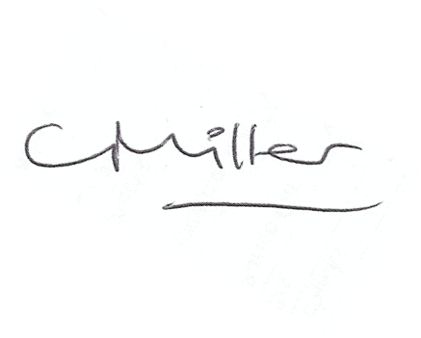
Claire Miller, Parish Clerk, 24th August 2018

