KIRKWHELPINGTON PARISH COUNCIL
AGENDA
Agenda for ordinary meeting of Kirkwhelpington Parish Council to be held at the Memorial Hall, Kirkwhelpington on Tuesday 2nd July 2019 commencing 730pm
2019/40 Apologies for Absence
2019/41 Declarations of Interest
2019/42 Public questions
2019/43 Co-Option Vacancy
2019/44 Minutes of previous meeting held Tuesday 7th May 2019
2019/45 Matters arising from previous meeting held Tuesday 7th May 2019
- Meadowlands Wall
- Trees
- Village web-site
- Seat repair
- Purchase of goalposts
- Play area repairs
- Reflective posts
- Overgrown honeysuckle
2019/46 Correspondence: Tynedale Hospice at Home newsletter
2019/47 Finance
2019/47/01 Bank Balance: £17210.40 as at 30/06/19
2019/47/02 The following accounts require authorisation:
- Kirkwhelpington Memorial Hall – W/C maintenance - £255.50;
- C Miller – May, June salary and expenses – £265.39
- HMRC - PAYE on above - £57.20
- Robson & Cowan – nylon head £33.13; fuel - £82.90
- ROSPA – annual play area inspection - £107.40

2019/48 Planning Matters
2019/49/01 Planning Applications received
2019/49/02 Approval of Planning Application
2019/49/03 Wannies Ascension sculpture
2019/50 Update on Ray Fell Wind Farm/Community Interest Company
Underground heating proposals; Feasibility study regarding engaging with youths; floral scheme
2019/51 Annual play area inspection
2019/52 Urgent Business
2019/53 Date of next Meeting
Dated this 19th day of June
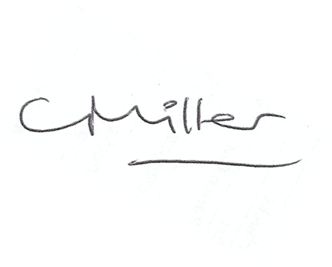
Claire Miller, Parish Clerk

