KIRKWHELPINGTON PARISH COUNCIL
AGENDA
Agenda for meeting of Kirkwhelpington Parish Council to be held at the Memorial Hall, Kirkwhelpington on Tuesday 5th March 2019 at 7.30pm
2019/13 Apologies for Absence
2019/14 Declarations of Interest
2019/15 Public questions
2019/16 Minutes of previous meeting held Tuesday 8th January 2019
2019/17 Matters arising from previous meeting held Tuesday 8th January 2019
- Meadowlands Wall
- Trees
- St Oswald’s Way signpost
- Proposed path between Kirkwhelpington and Knowesgate
- Village web-site
- Seat repair
- Purchase of goalposts
2019/18 Correspondence
- Northumberland Draft Local Plan – Consultation 30/1 to 13/3/19
- CPRE newsletter
- City & County newsletter
2019/19 Finance
2019/19/01 Bank Balance: £26211.92 as at 28/02/19
2019/19/02 The following accounts require authorisation:
- Kirkwhelpington Memorial Hall – W/C maintenance - £255.50;
- C Miller – January, February salary and expenses – £ 259.13
- HMRC - PAYE on above - £55.40
- Goalposts - £1050.00
2019/19/03 Request for grant received from North East War Memorials Project; Northumberland Theatre Company
2019/19/04 To approve amendments to bank signatories and on-line banking

2019/20 Planning Matters
2019/20/01 Planning Applications received
2019/20/02 Approval of Planning Application

2019/21 Update on Ray Fell Wind Farm/Community Interest Company
Underground heating proposals:
2019/22 Review of Internal Auditor/internal controls; Asset Register; Risk Assessment and Insurance Policy
2019/23 To confirm grasscutting arrangements 2019/2020
2019/24 Urgent Business

2019/25 Date of next Meeting
Dated this 22nd day of February

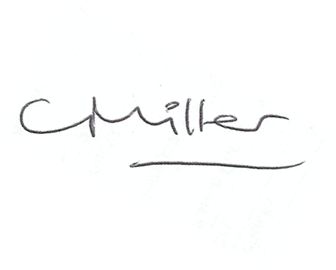
Claire Miller, Parish Clerk

